**Azure AD B2C**, **Microsoft Graph API**, and **API authentication**

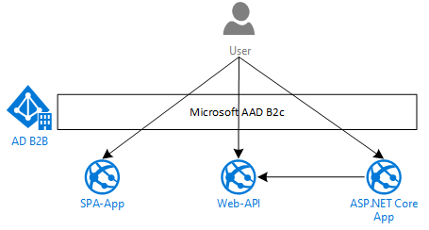

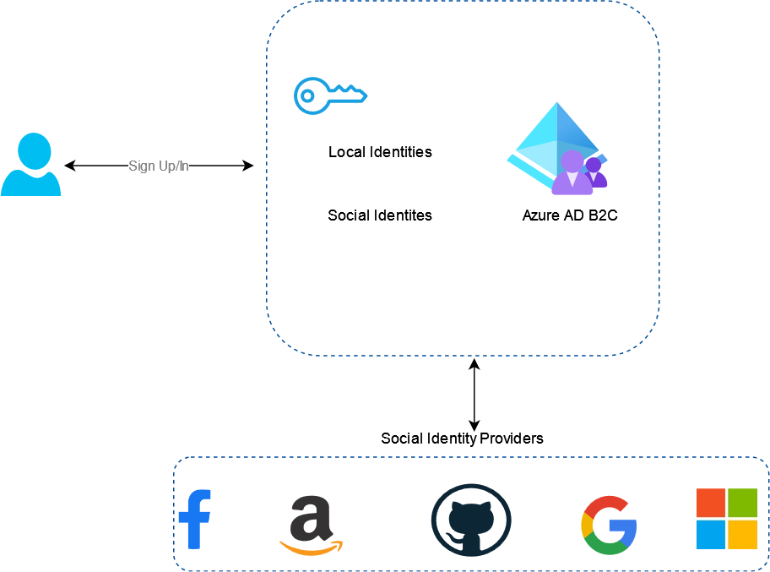

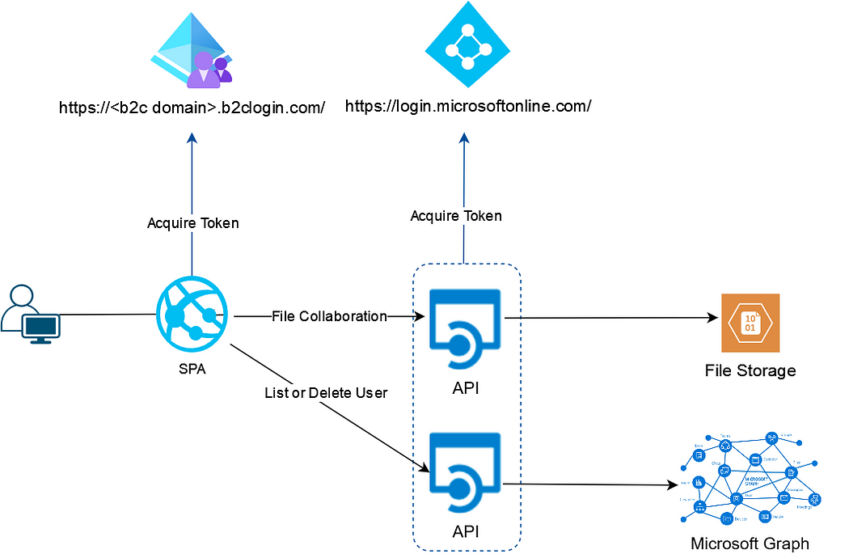

we developed SPA with MSAL for Angular, Azure AD B2C user sign-in sign-up flow, Azure AD B2C protected .NET API and user account management through Microsoft graph API.

**Infrastructure Architecture**

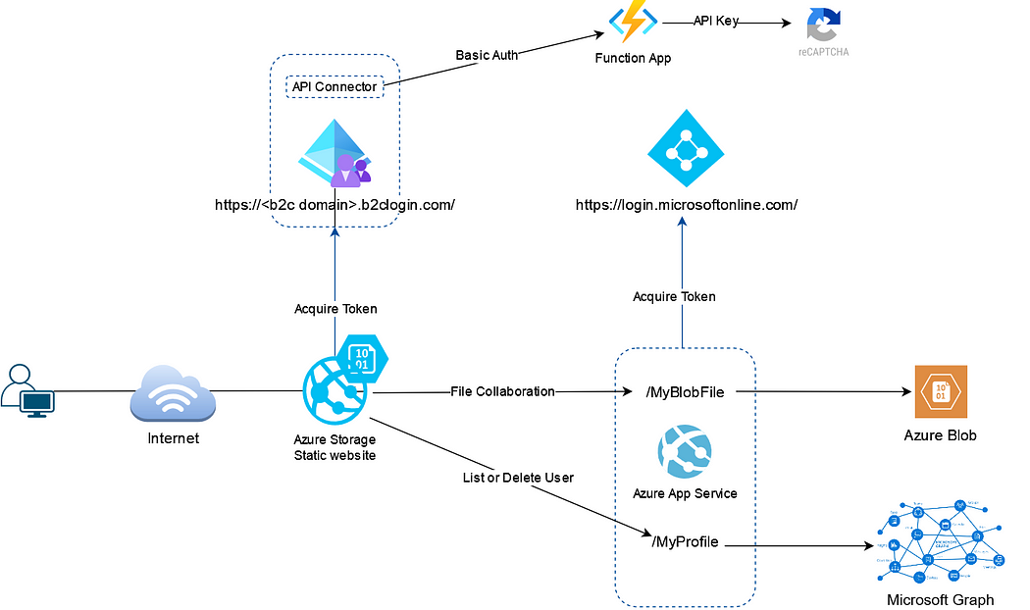

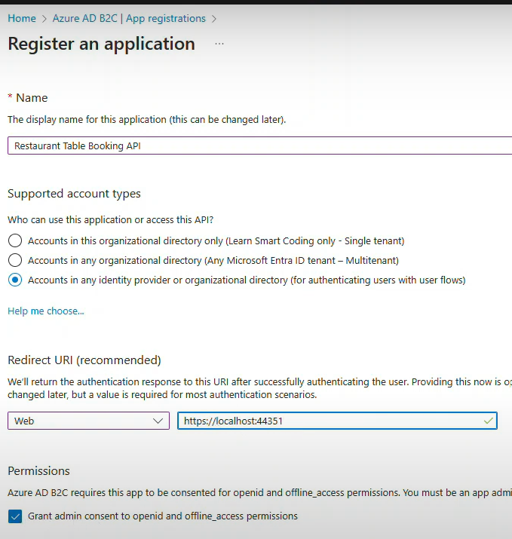

All scope will be inside url

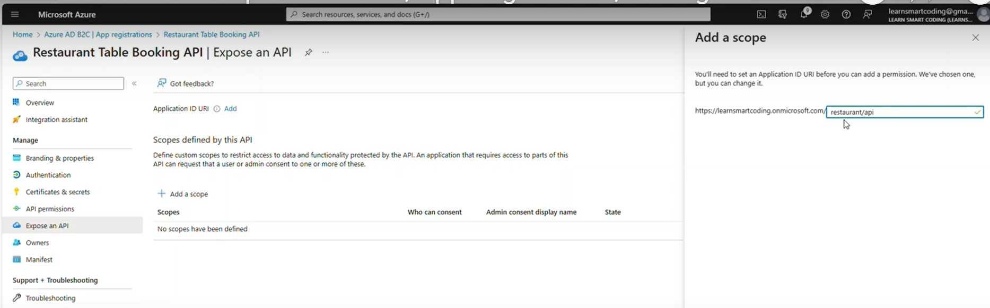

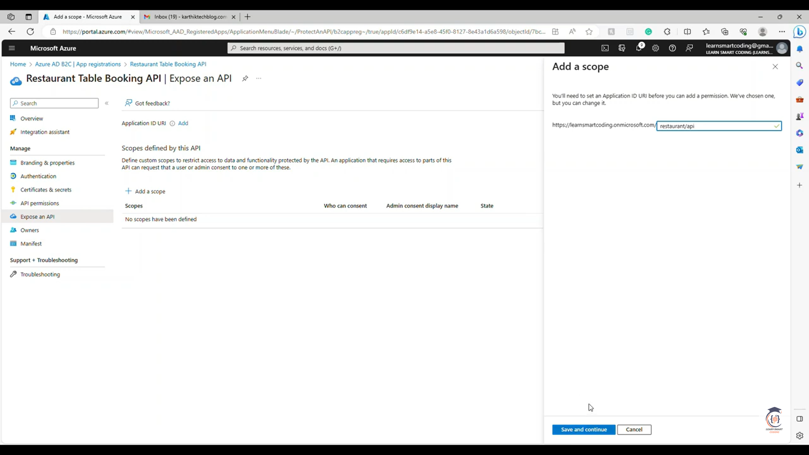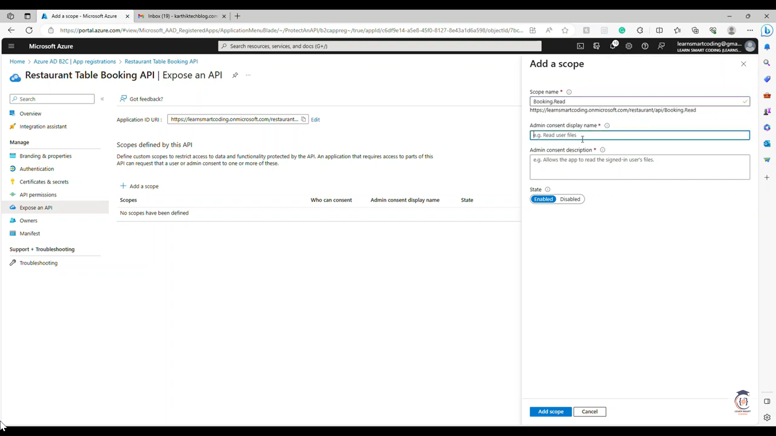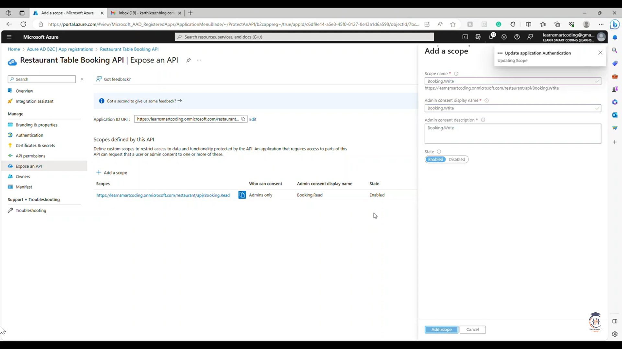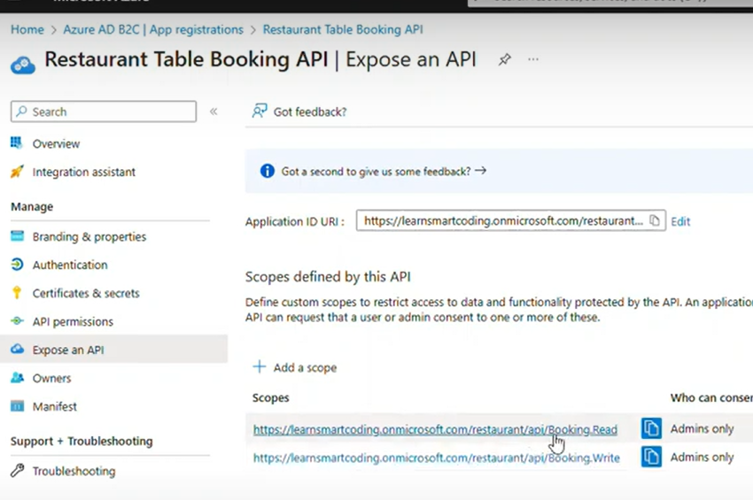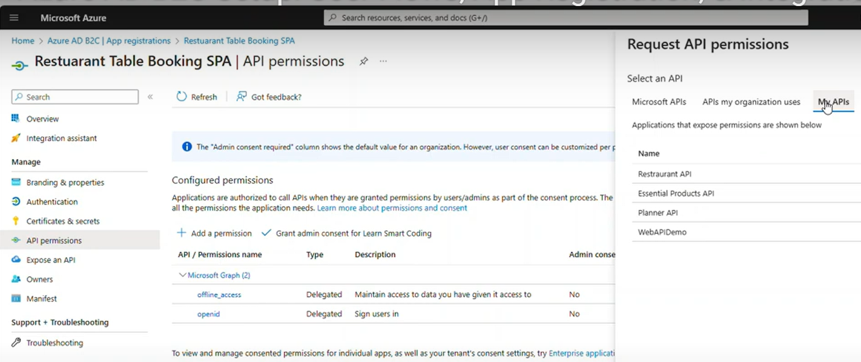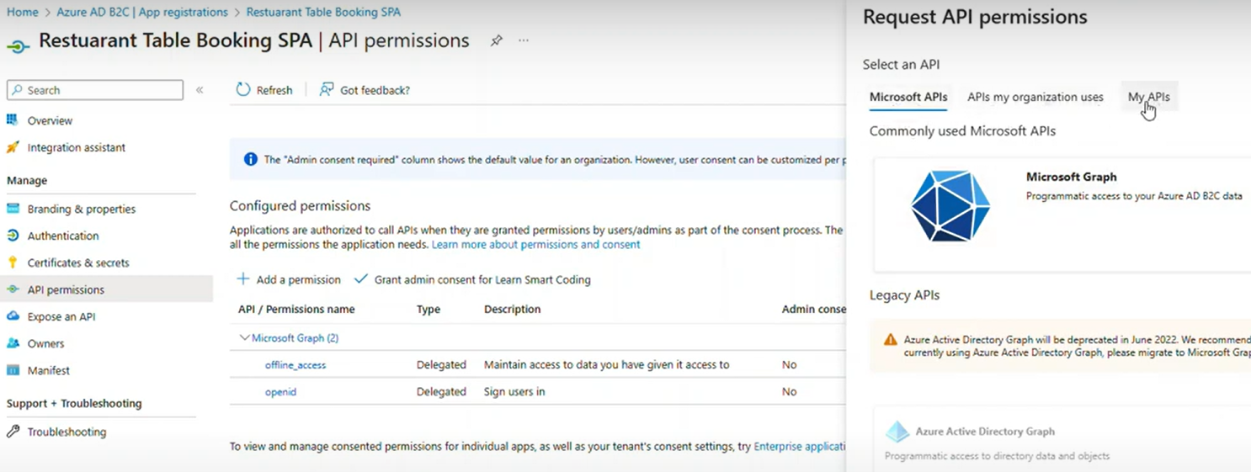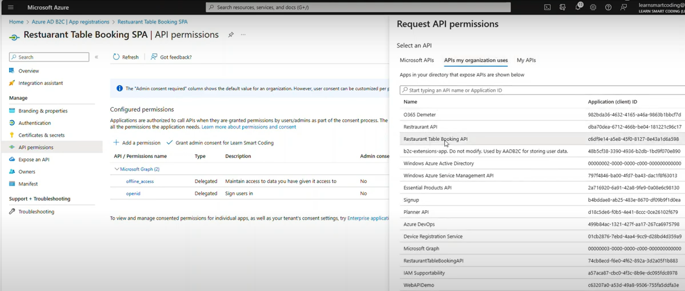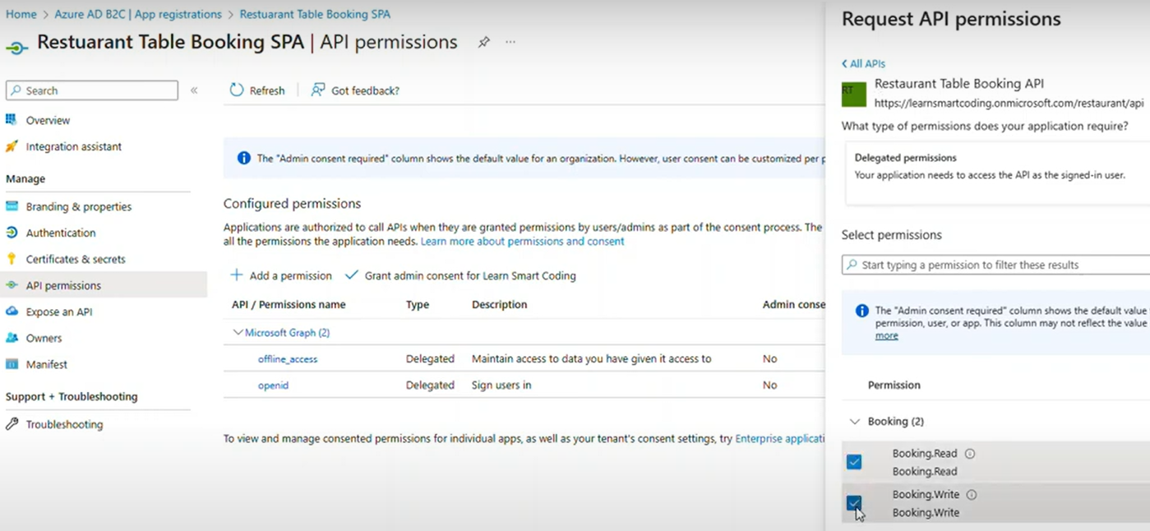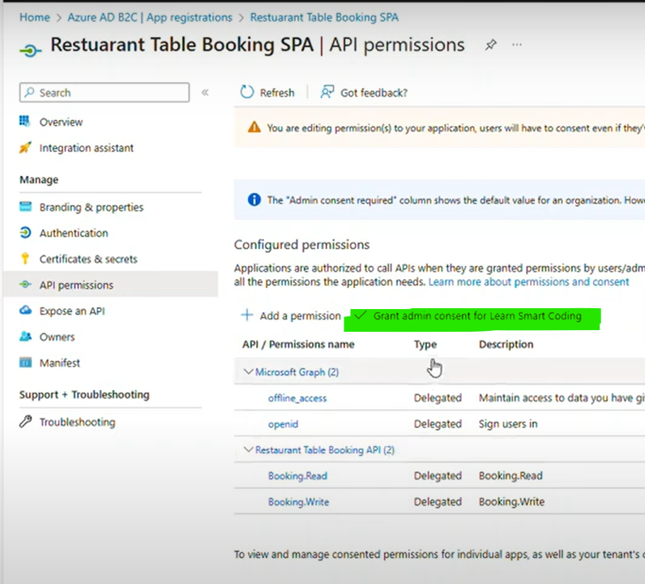

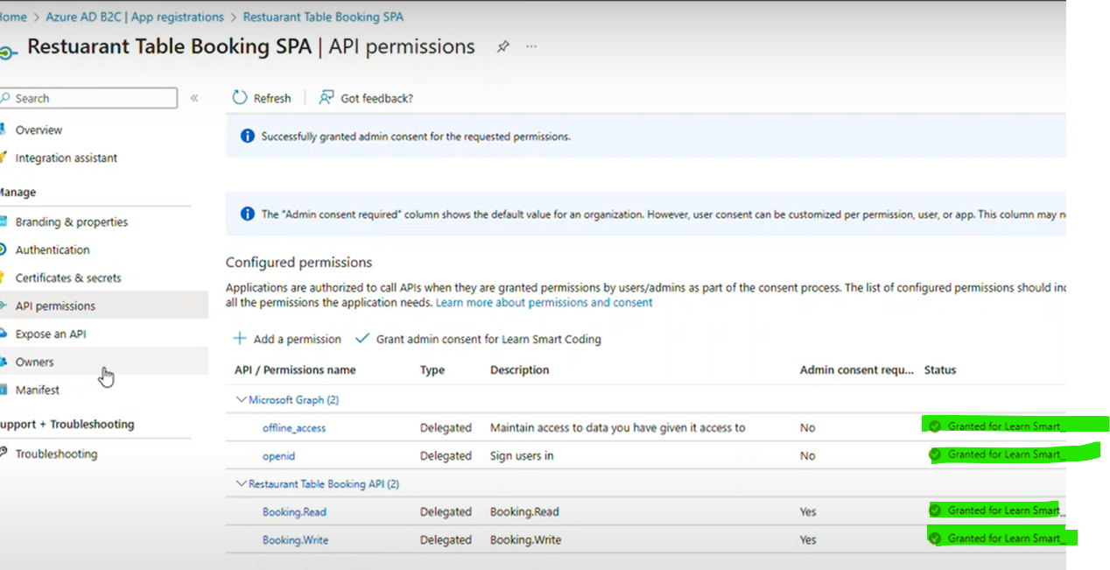

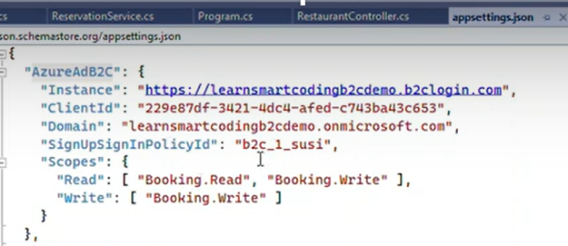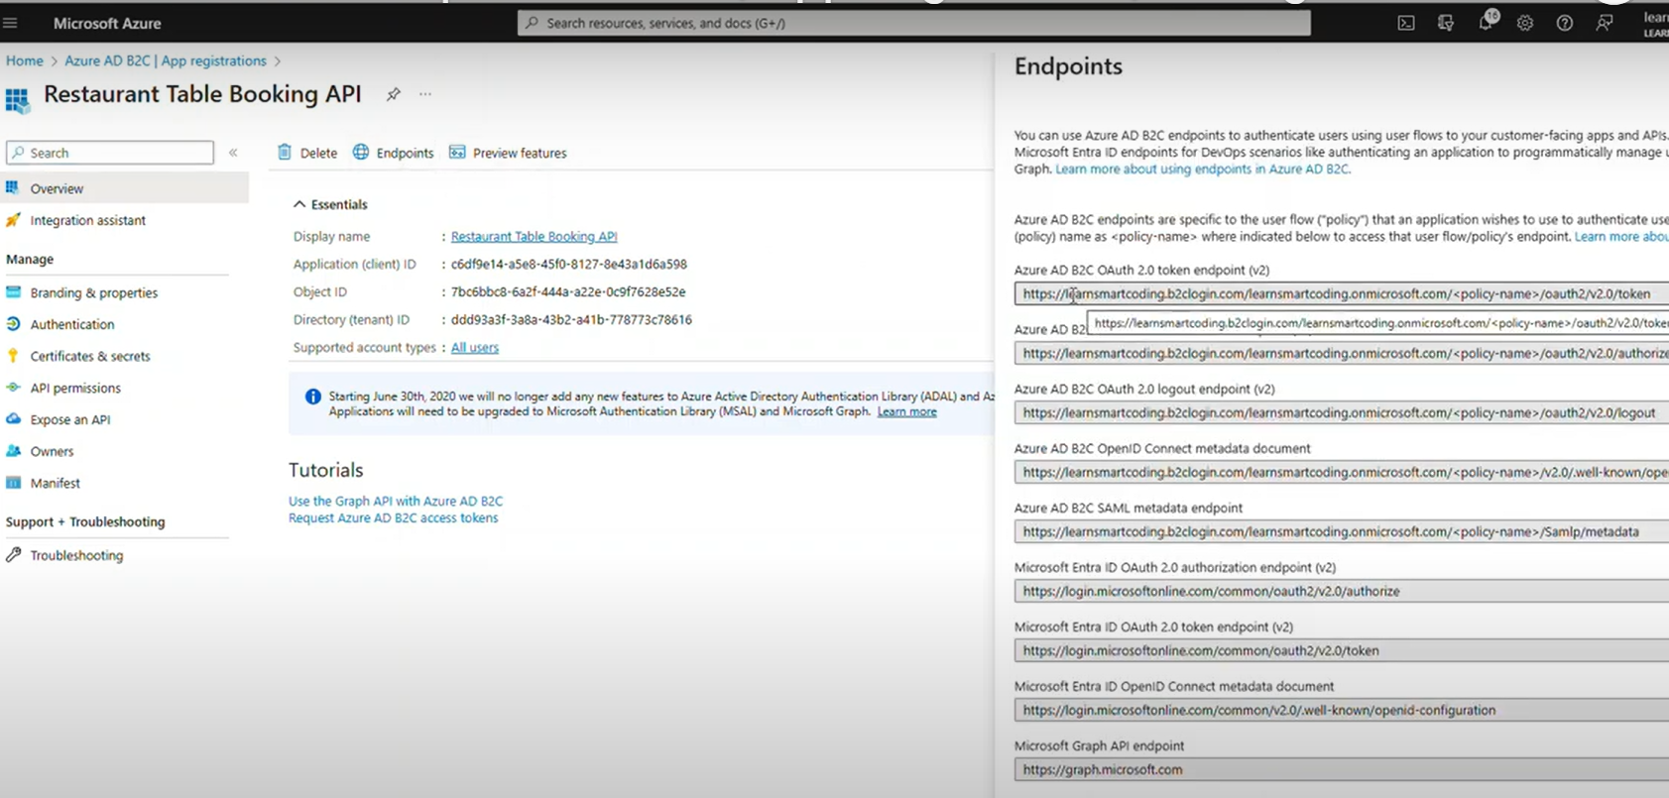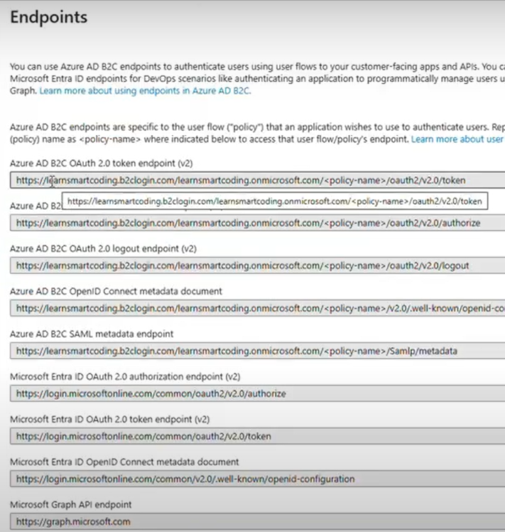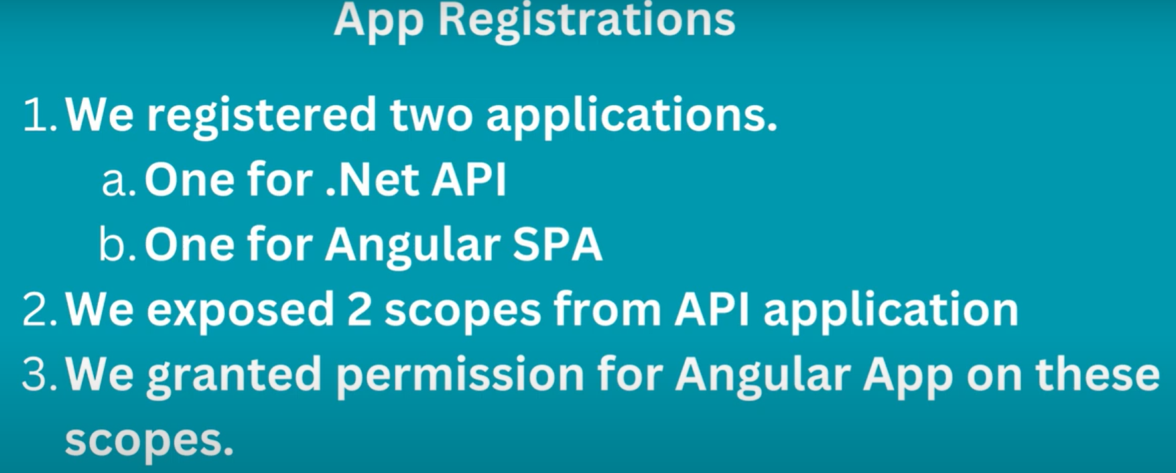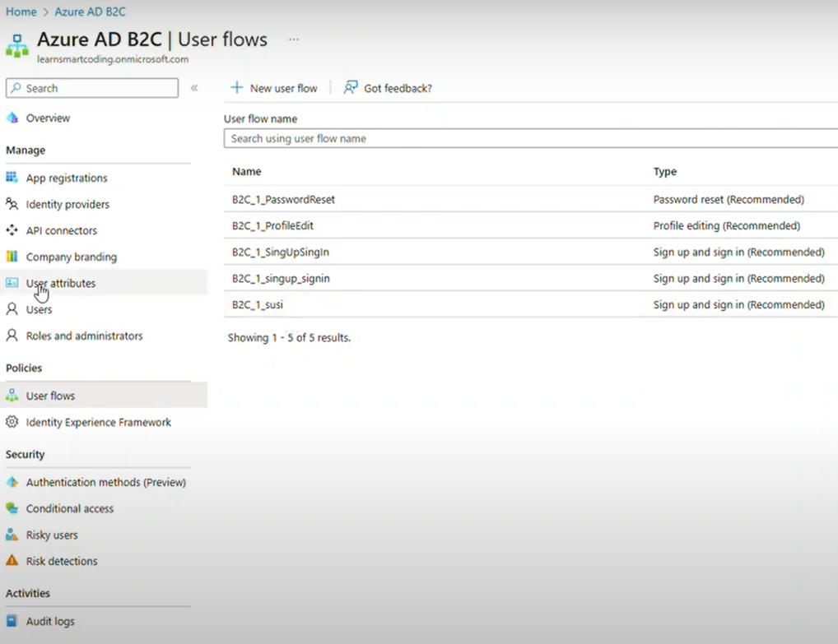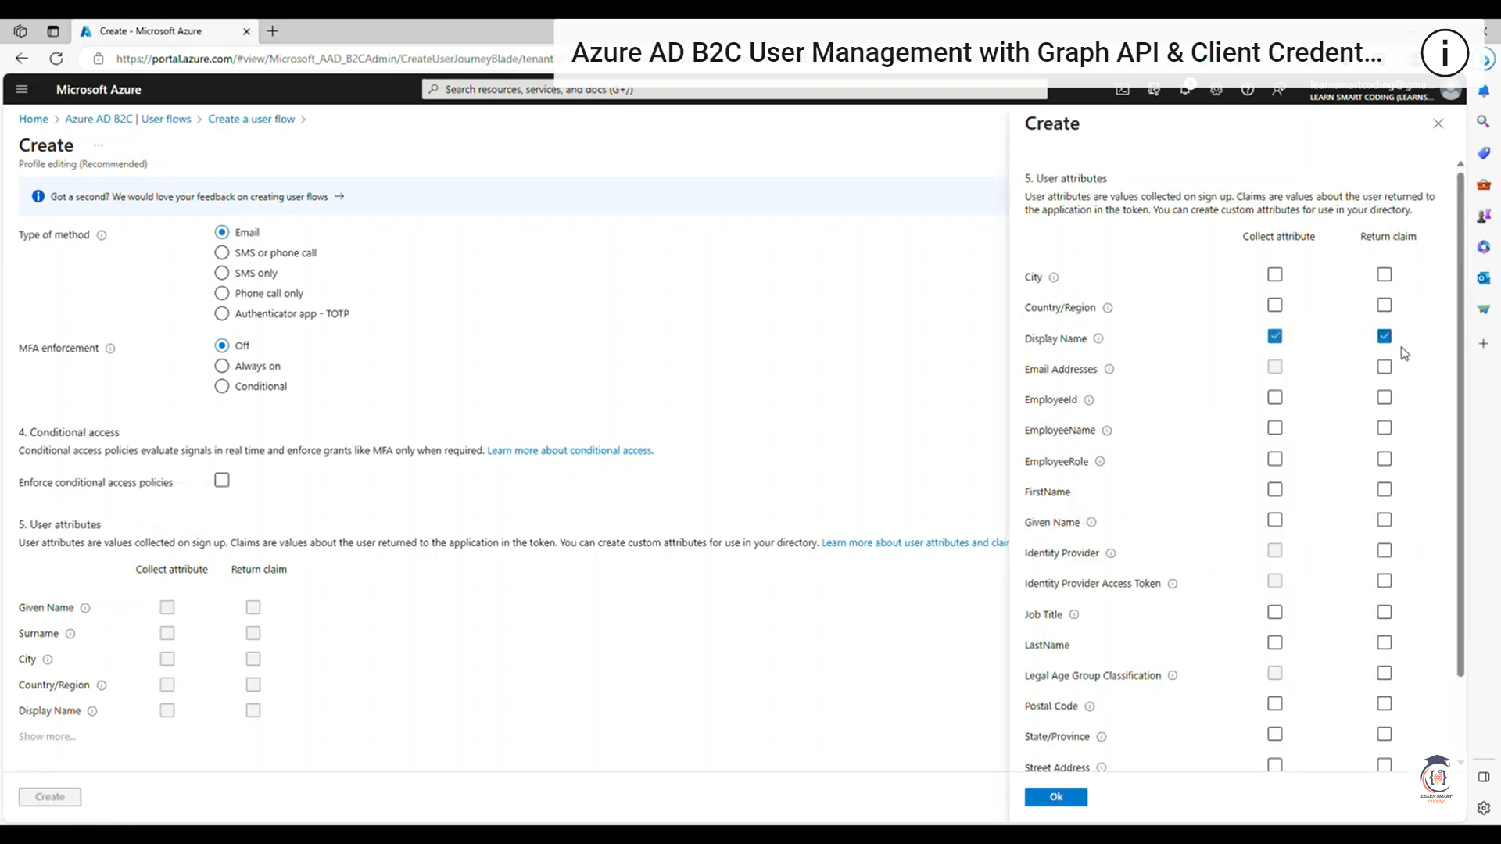profile edit page

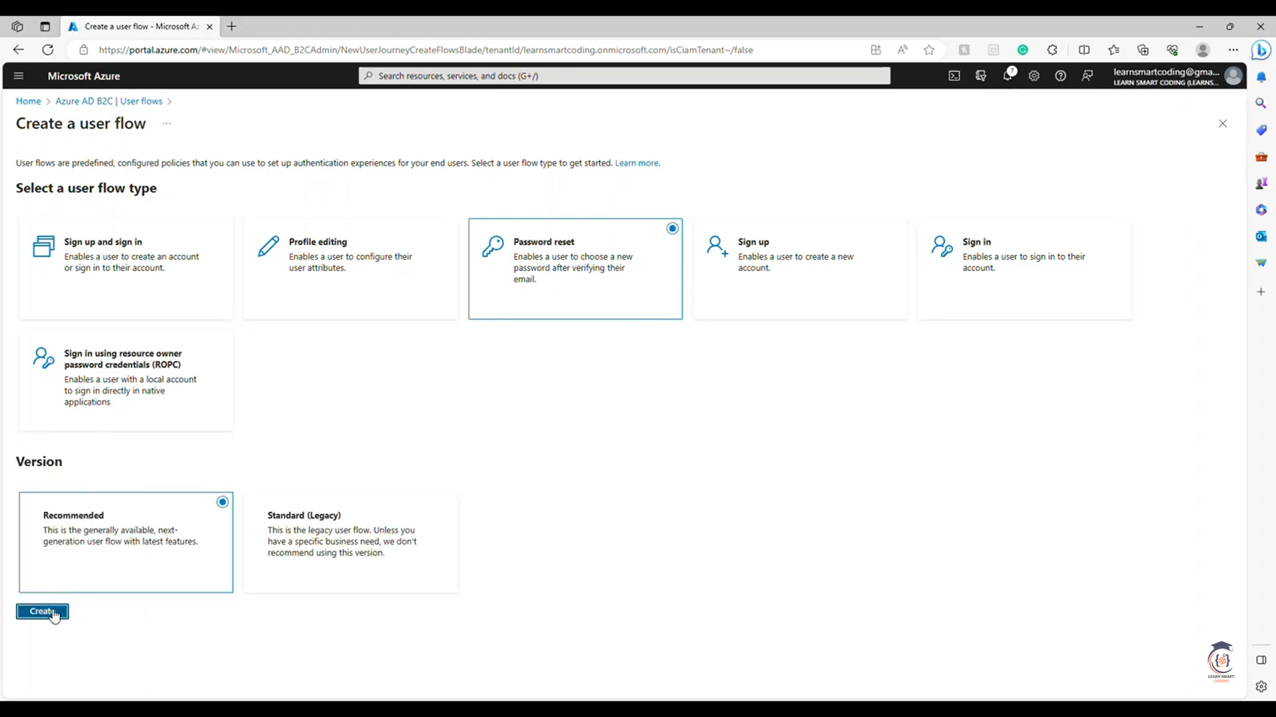

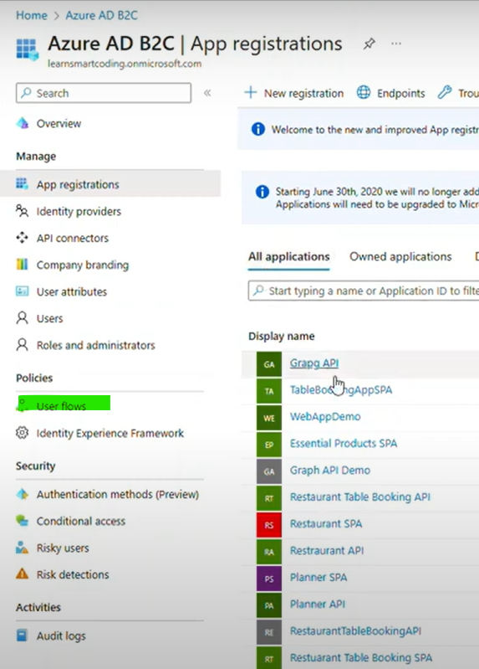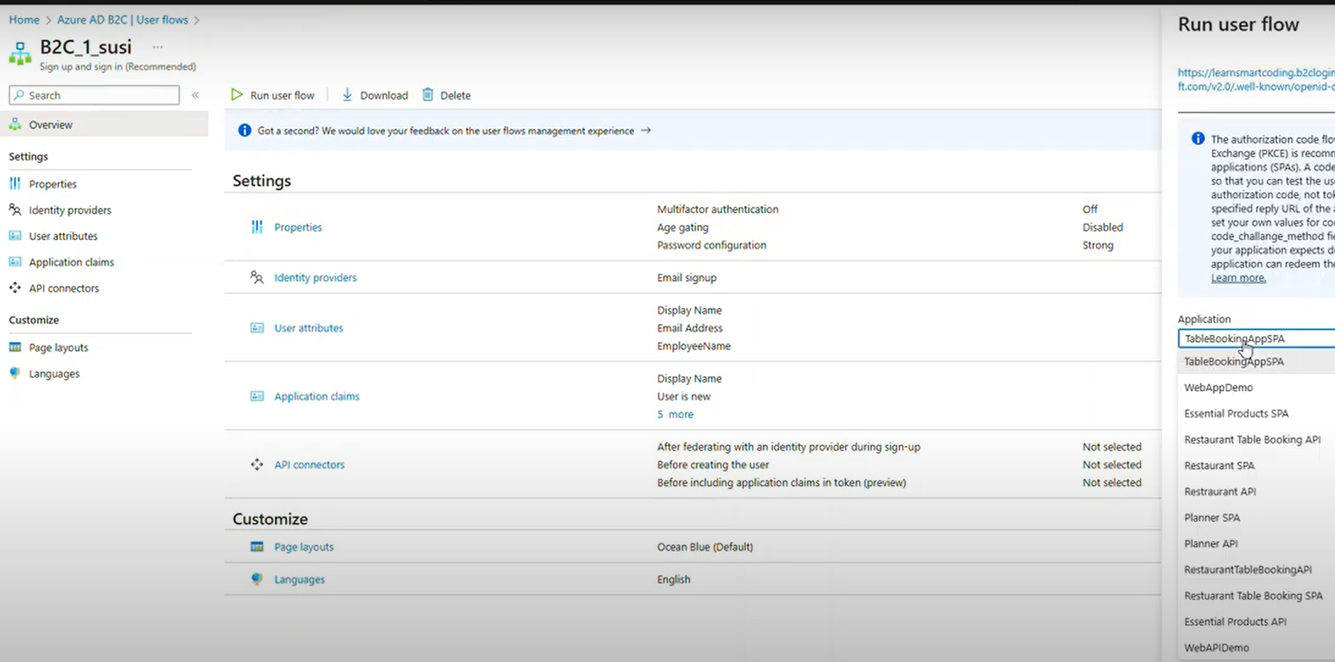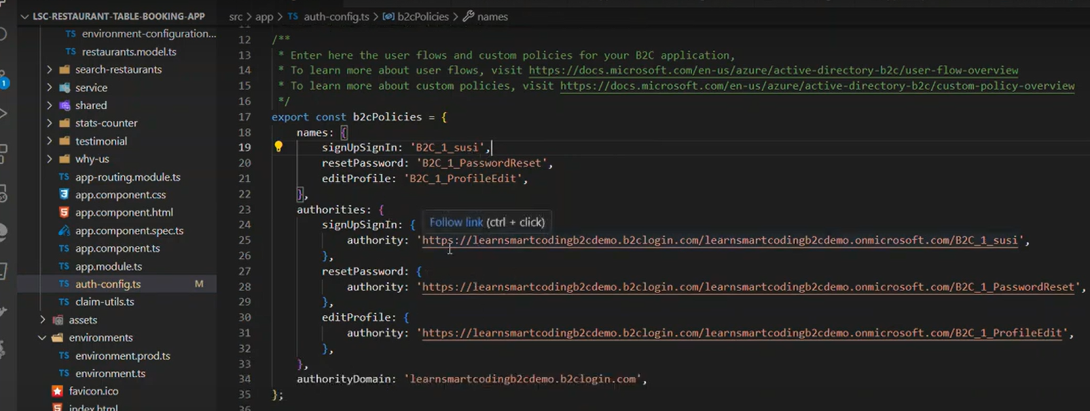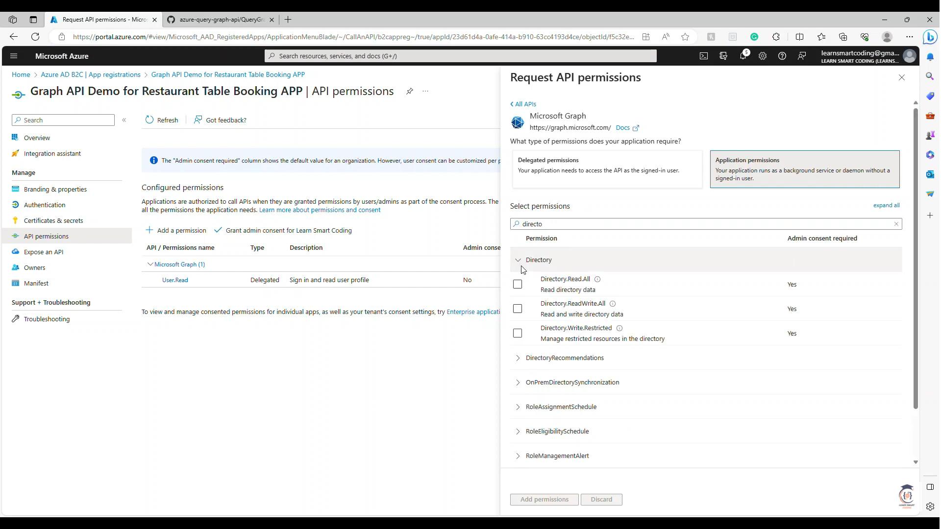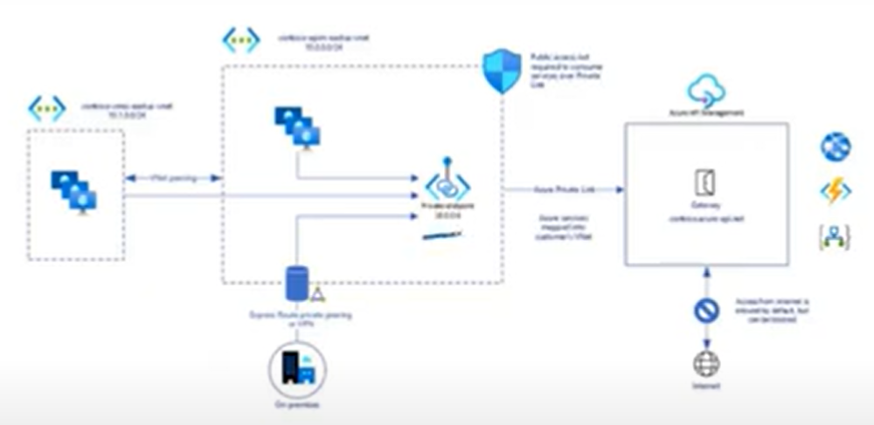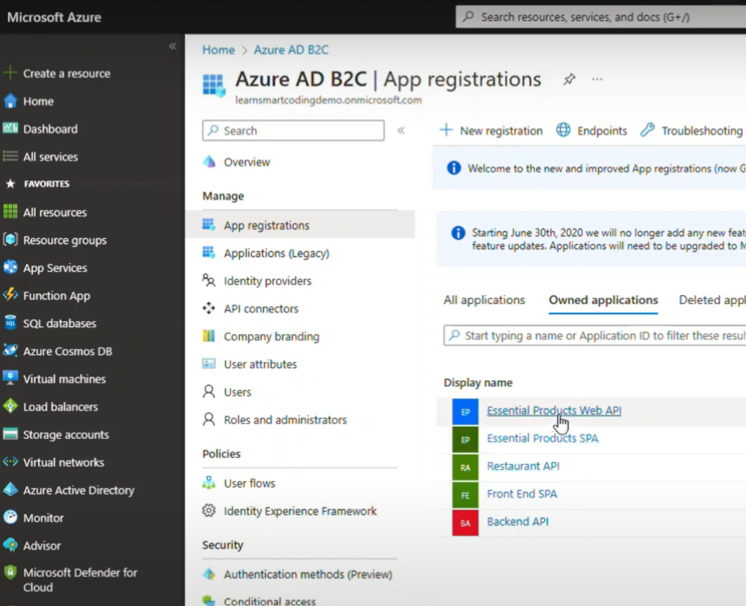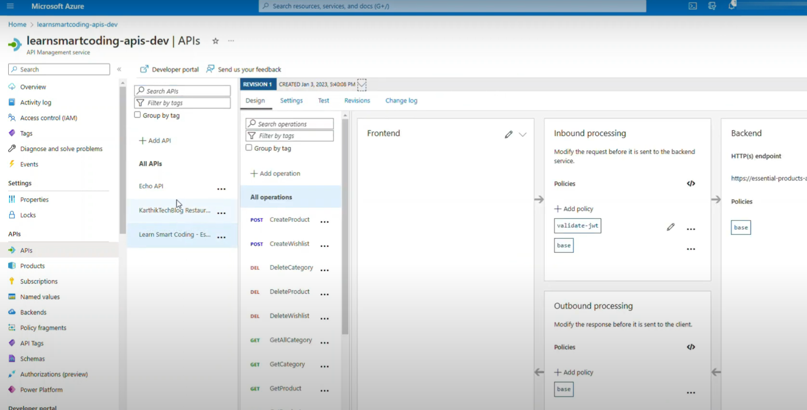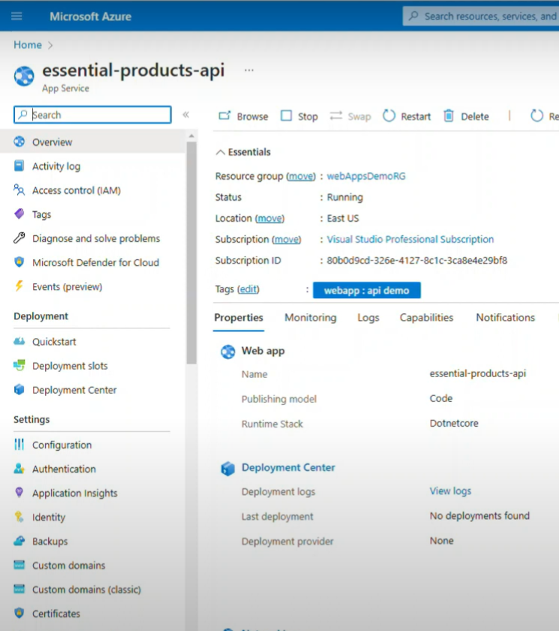

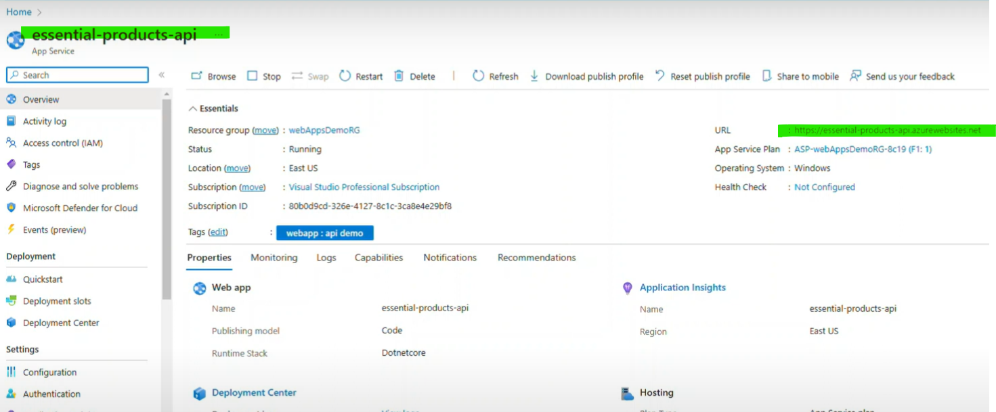

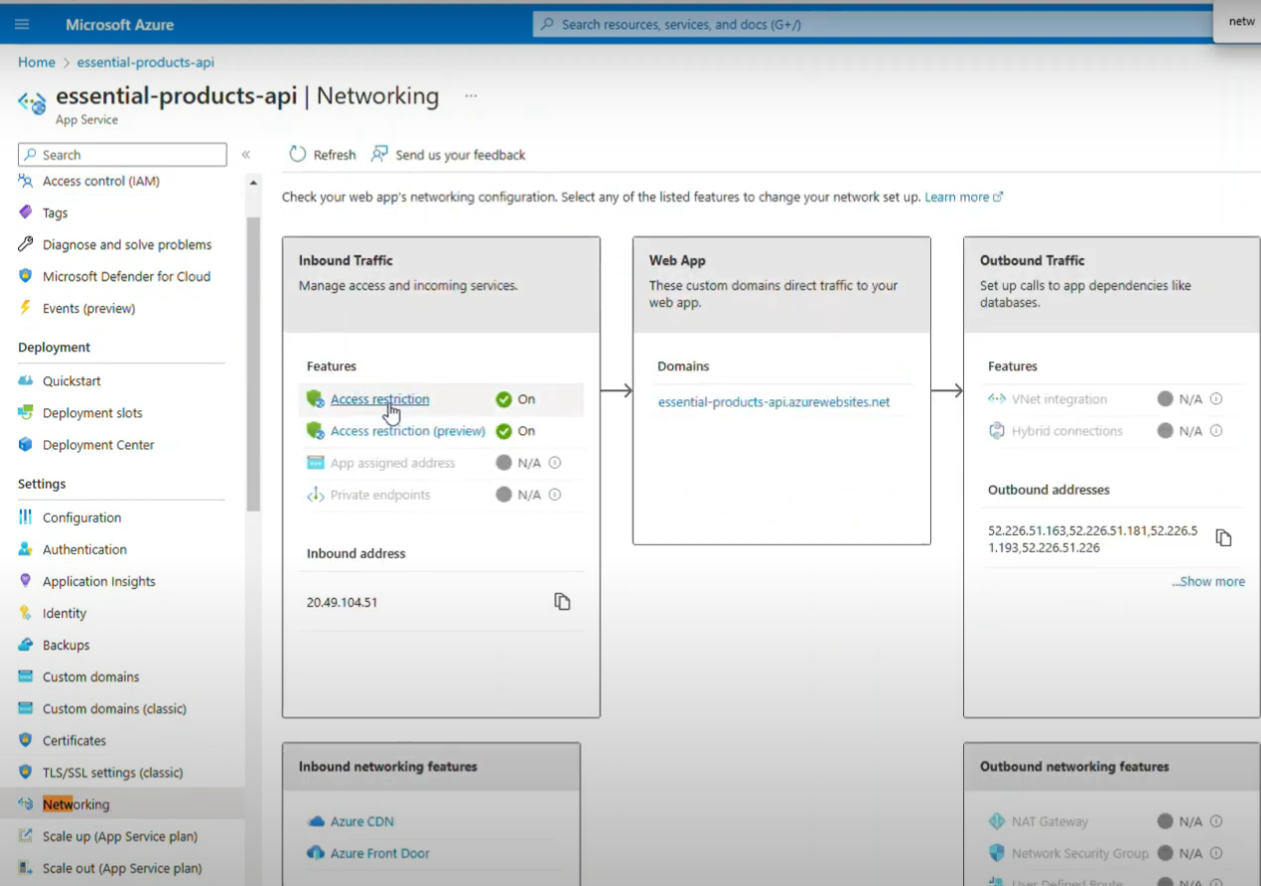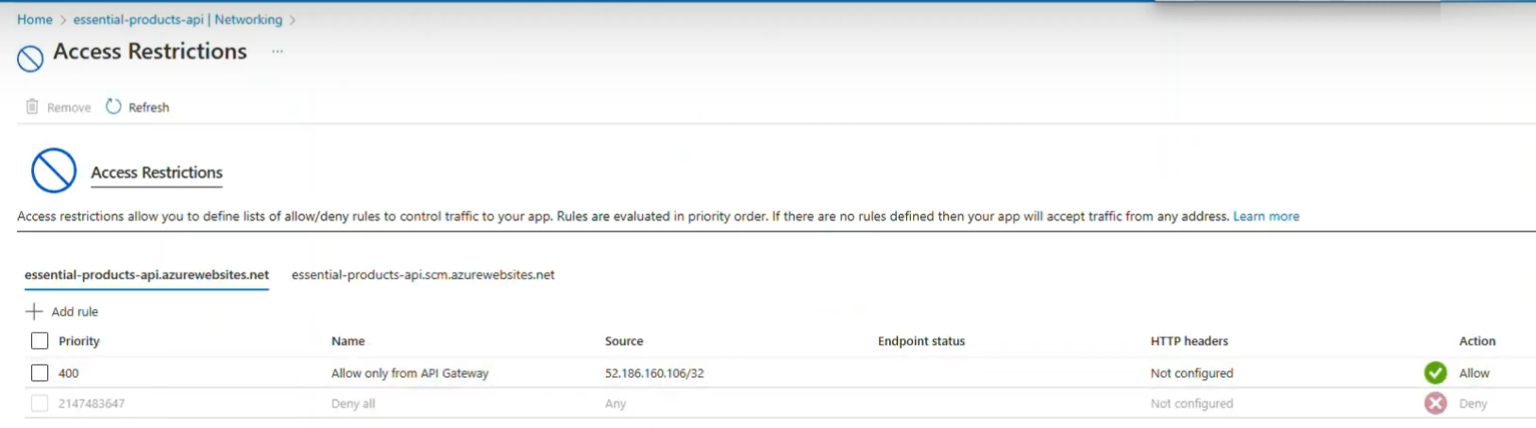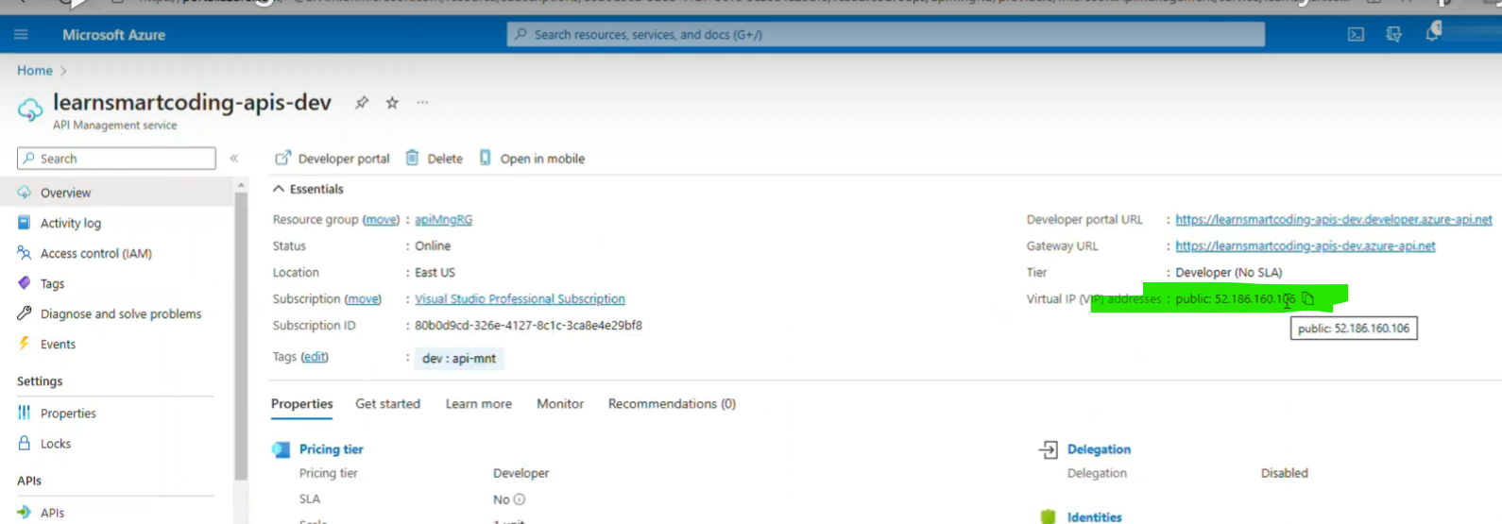

Url link , Audience, Issuer

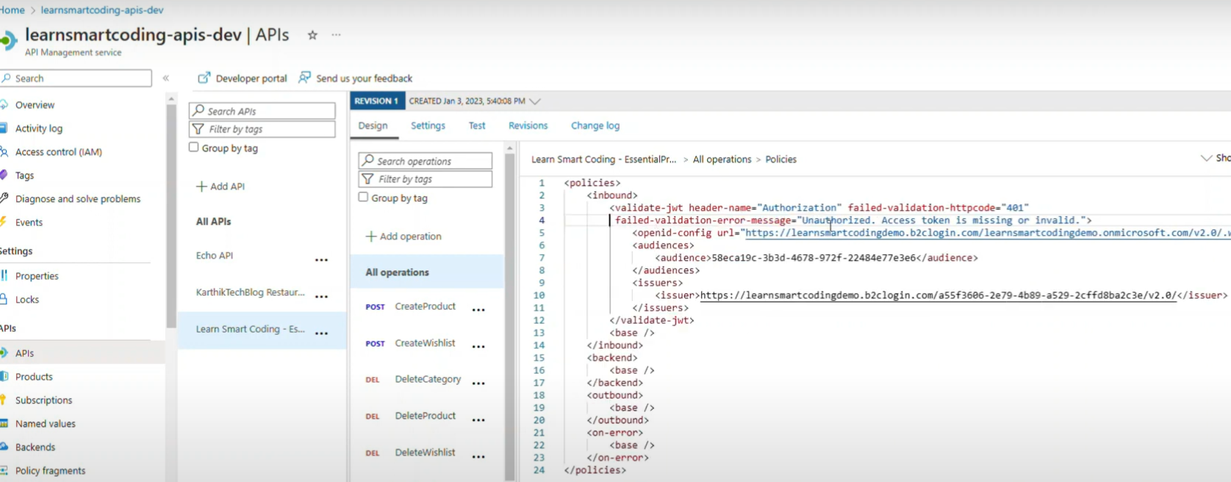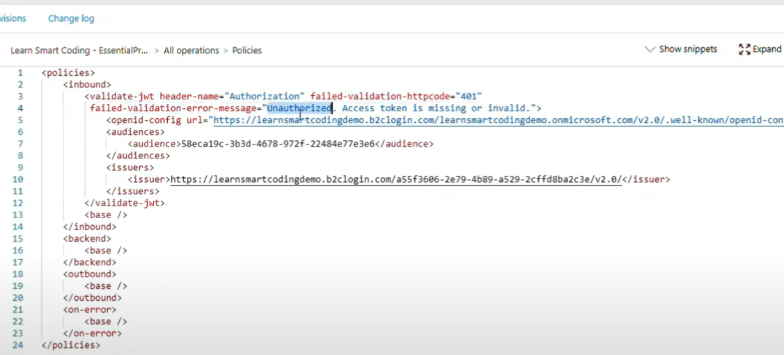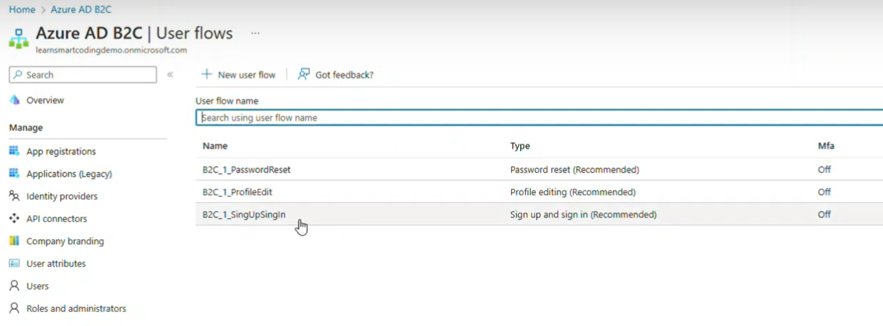

Click on Run Userflow

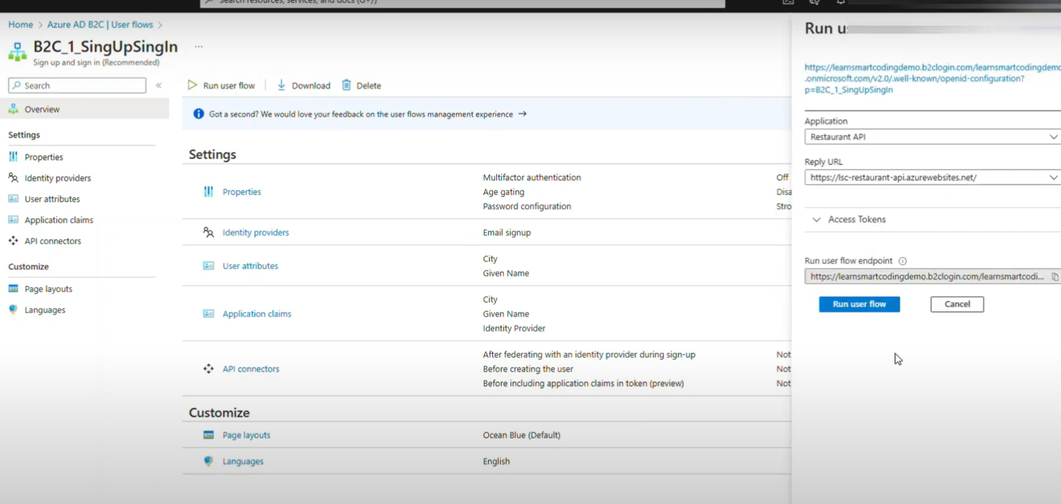

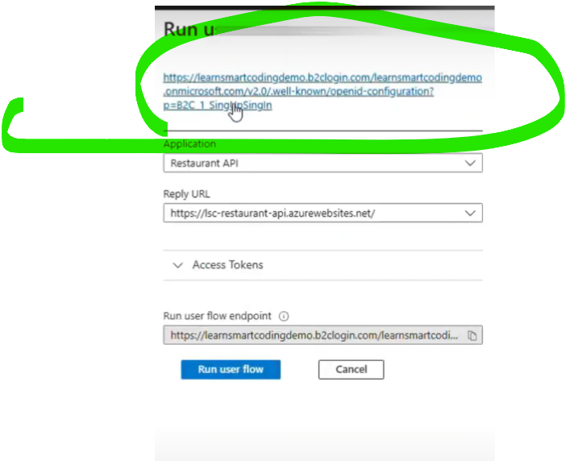

Paste url here…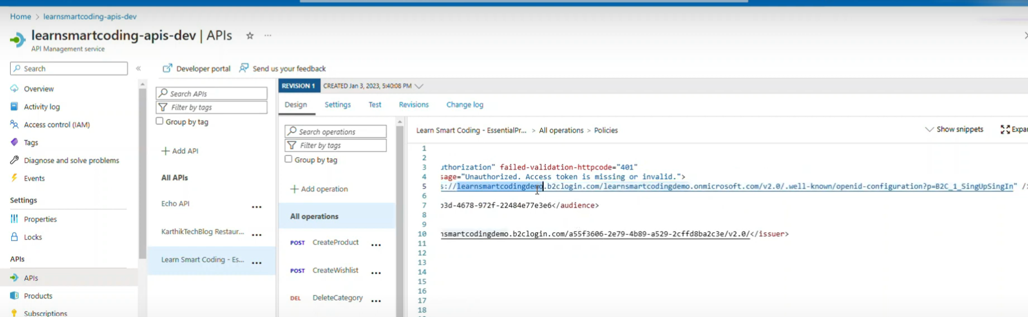

Inside url (audience)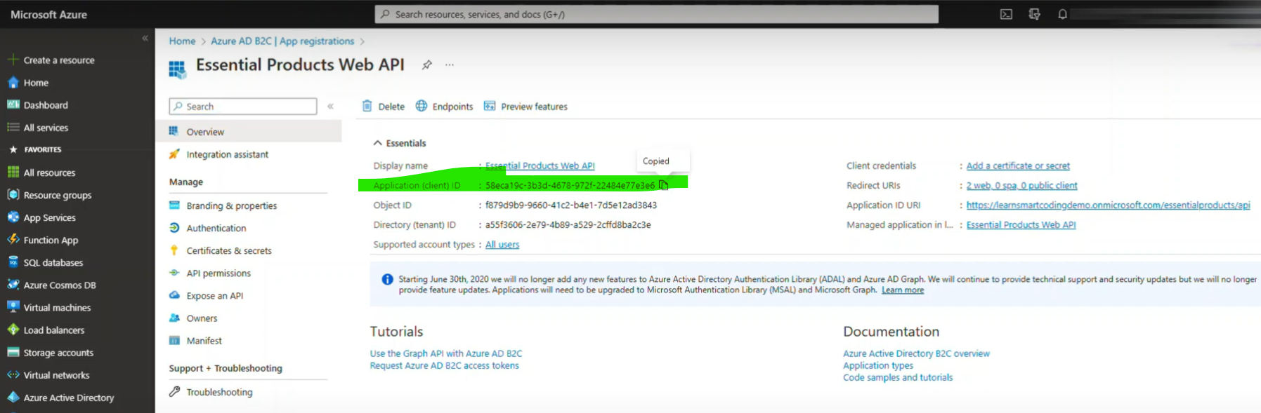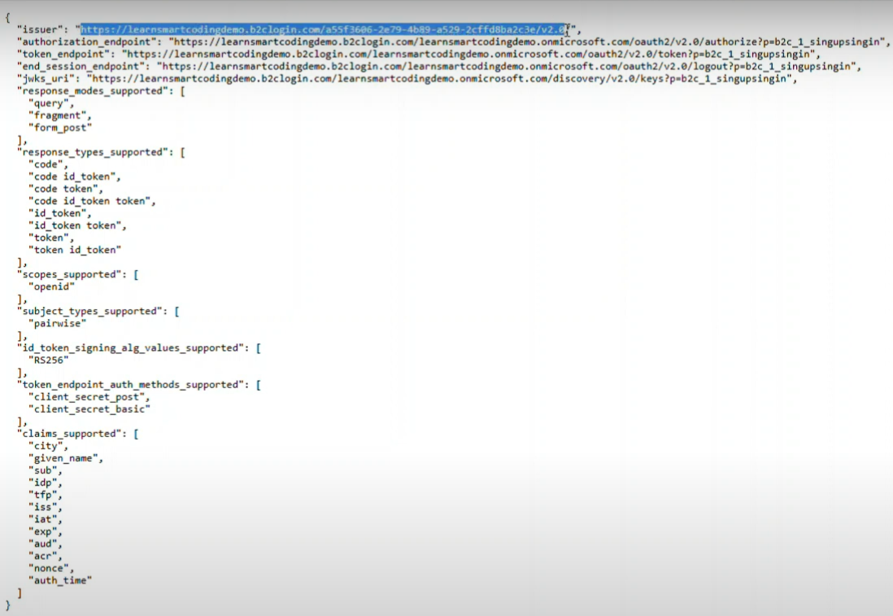

Now from UI Side

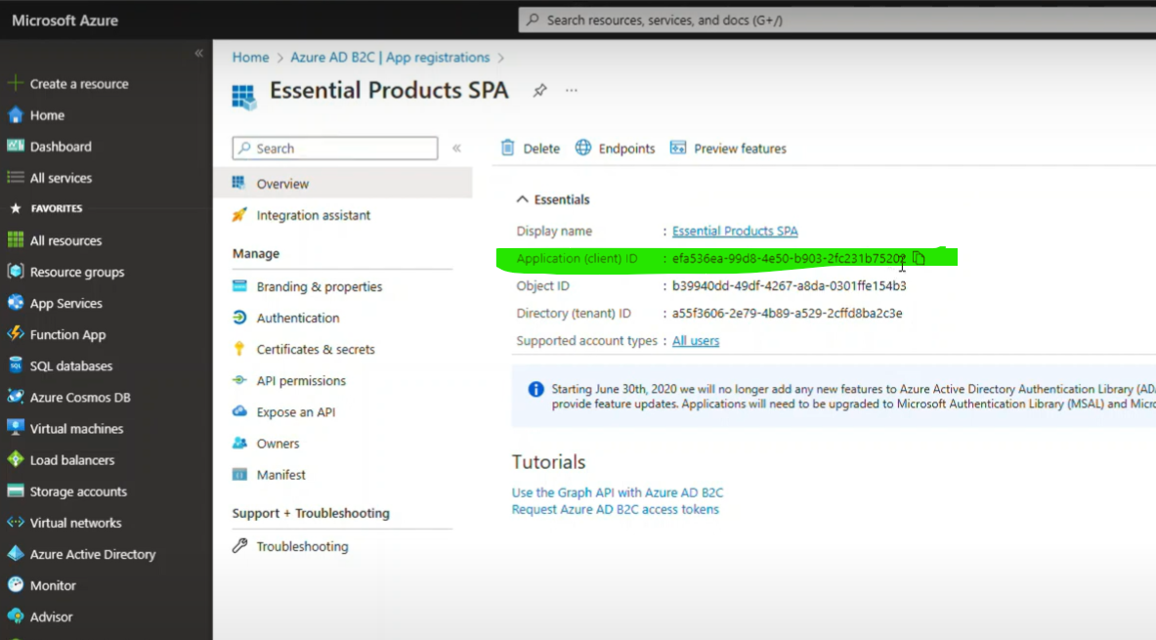

Client id for uI replace

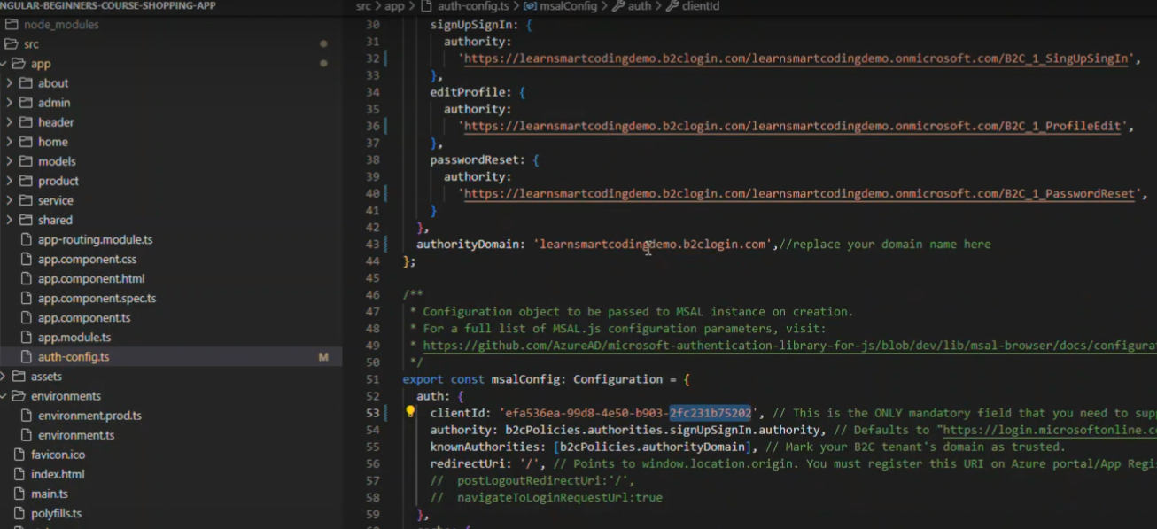

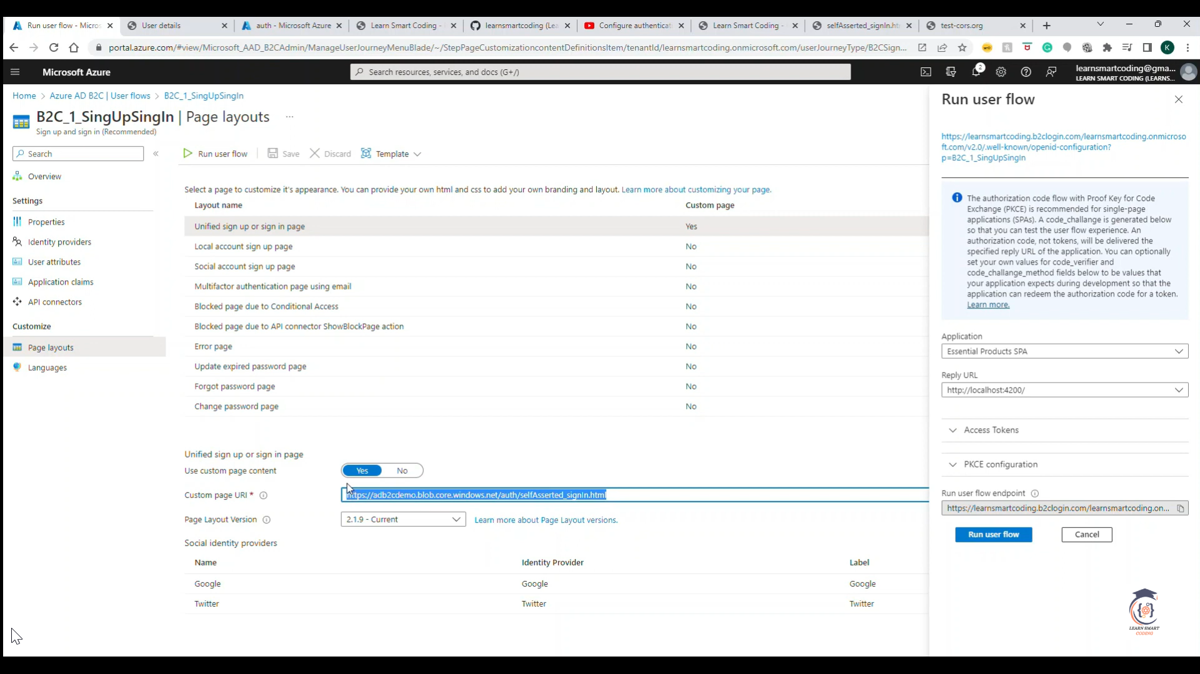

CDN

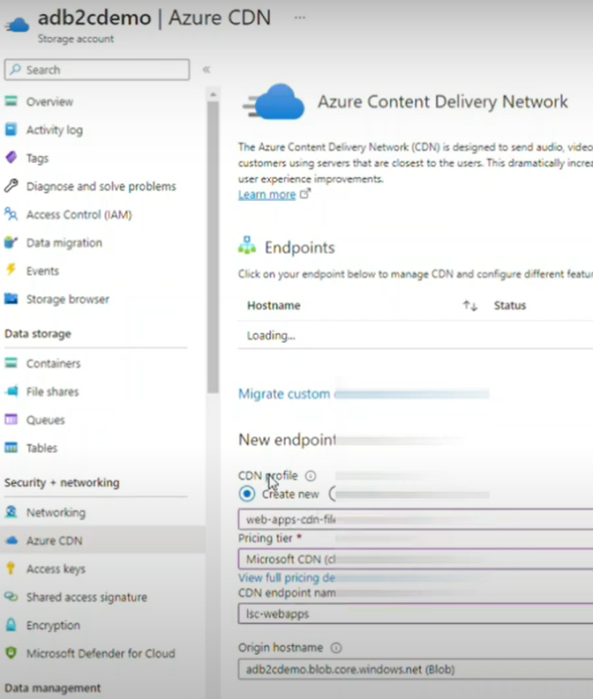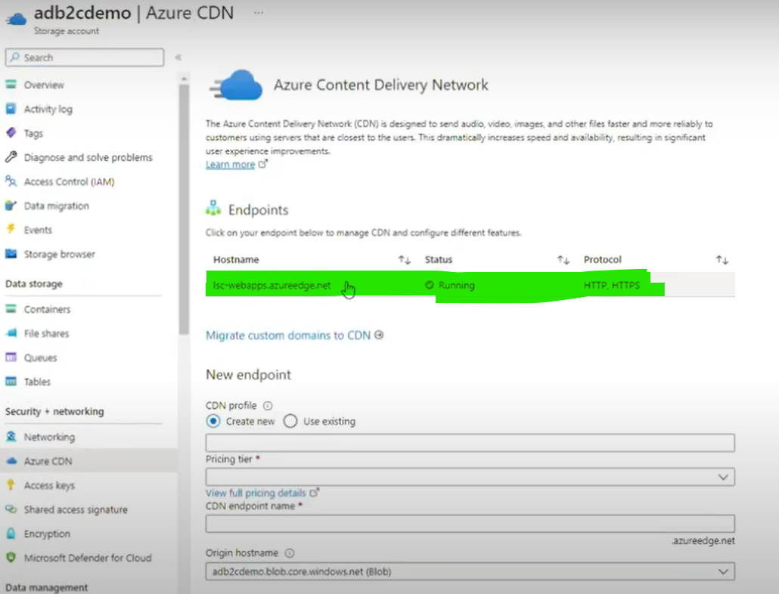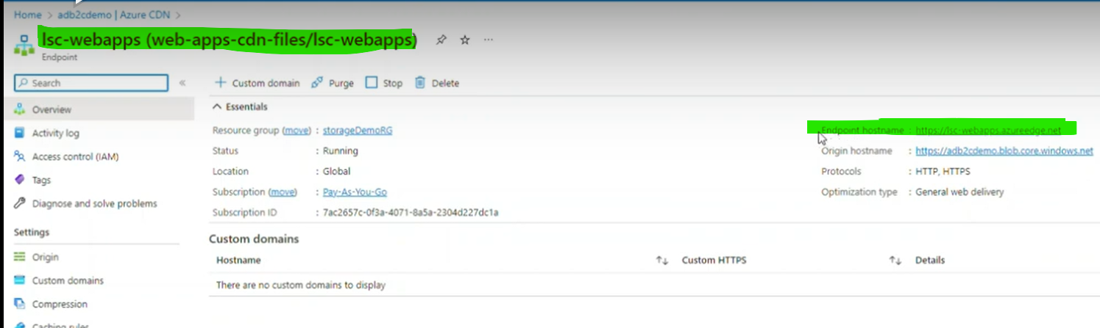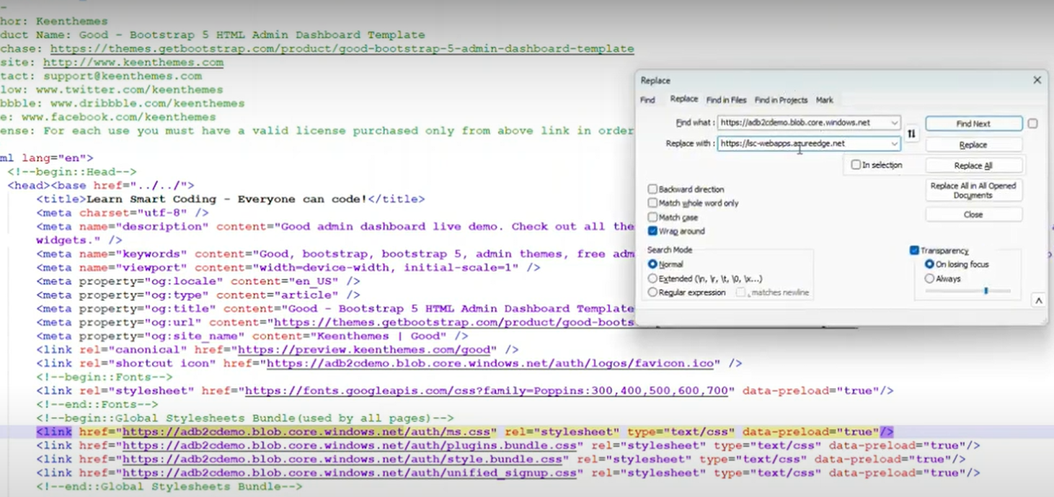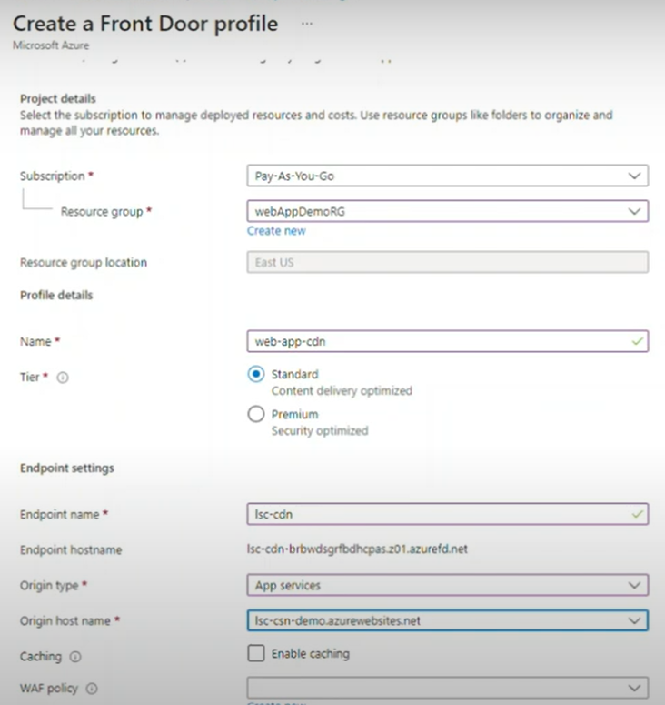

Google sign in

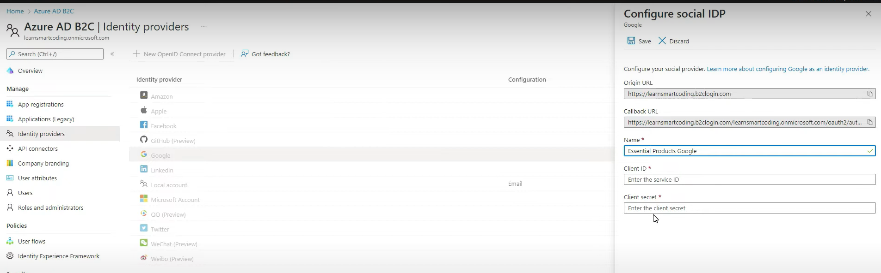

Here’s an expanded table format for **Solution Architect interview preparation** that highlights **key best practices** with additional examples:

| **Best Practice** | **Description** | **Examples** |
| --- | --- | --- |
| **Comprehensive Discovery** | Involve key stakeholders early to gather requirements and understand goals. | - Conduct workshops with business leaders and technical teams. - Ask open-ended questions to uncover tribal knowledge. - Use tools like surveys or interviews for requirement gathering. |
| **Document Everything** | Maintain detailed documentation for all solution aspects. | - Create architecture diagrams using tools like **Visio** or **Lucidchart**. - Document functional and non-functional requirements. - Maintain an updated backlog and version-controlled artifacts. |
| **Iterate and Validate** | Continuously iterate on the solution and validate with stakeholders. | - Develop **Proof of Concepts (POCs)** to validate technical feasibility. - Use Agile sprints for iterative delivery. - Gather regular feedback via demos or stand-up meetings. |
| **Stay Responsive and Available** | Be available to address concerns and provide ongoing support. | - Set up **SLAs** for timely responses. - Offer post-implementation support plans. - Be proactive in resolving issues and answering queries. |
| **Demonstrate Value Clearly** | Showcase how the solution aligns with business goals and delivers ROI. | - Present use-case scenarios demonstrating business benefits. - Use metrics like cost savings, scalability, and performance improvements. - Provide comparative analysis between existing systems and the proposed solution. |
| **Ensure Ease of Integration** | Design solutions that integrate seamlessly with existing systems. | - Use Azure services like **Azure Logic Apps**, **API Management**, and **Service Bus**. - Conduct integration testing to identify potential issues. - Provide clear integration documentation for developers. |
| **Focus on Scalability and Performance** | Build solutions that can scale with business needs while ensuring performance. | - Leverage Azure PaaS services like **Azure App Services** and **Azure SQL Database**. - Use tools like **Azure Monitor** and **Application Insights** for performance monitoring. - Conduct load testing with tools like **JMeter**. |
| **Optimize Cost** | Design cost-effective solutions without compromising quality. | - Use Azure **Cost Management** to monitor spending. - Implement auto-scaling for resources to optimize usage. - Choose the right Azure pricing model (Pay-As-You-Go vs Reserved Instances). |
| **Provide Training and Documentation** | Ensure end-users and teams can adopt the solution effectively. | - Create user guides, FAQs, and technical documentation. - Conduct training sessions and workshops. - Use tools like **Confluence** or **SharePoint** for knowledge sharing. |
| **Security and Compliance** | Design solutions that meet security and regulatory requirements. | - Implement Azure **Security Center** and **Azure Policy**. - Follow best practices for data encryption, identity management, and access control. - Ensure compliance with standards like GDPR, HIPAA, or ISO. |

**"As a .NET Azure Solution Architect, I’ve encountered several challenges during solution design and implementation. Here are a few examples and how I resolved them:"**

**1. Challenge: Understanding Complex Business Requirements**

* **Situation:**  
  At the start of a project, the requirements were unclear, and stakeholders had different interpretations of the business objectives. This ambiguity made it difficult to design a solution aligned with their goals.
* **Resolution:**
  + Conducted **comprehensive discovery sessions** involving key stakeholders to gather and clarify requirements.
  + Used **active listening** techniques to uncover hidden pain points and tribal knowledge.
  + Developed a **Proof of Concept (POC)** to demonstrate the solution's feasibility and ensure alignment with business goals.
  + Maintained detailed **documentation** and iteratively validated the requirements with stakeholders through regular reviews.
* **Outcome:**  
  The POC provided clarity, and the solution was aligned with business objectives, leading to stakeholder confidence and successful project delivery.

**2. Challenge: Integrating Azure Solutions with Legacy Systems**

* **Situation:**  
  The customer had an on-premises legacy system that needed integration with Azure services. The legacy system lacked proper APIs and was incompatible with modern Azure components.
* **Resolution:**
  + Performed a **thorough assessment** of the existing system to identify integration challenges.
  + Leveraged **Azure Logic Apps** and **Azure API Management** to create a middleware layer for seamless integration.
  + Used **Azure Service Bus** for asynchronous messaging to ensure decoupling between the systems.
  + Conducted **integration testing** to validate the solution and provided clear documentation for the development team.
* **Outcome:**  
  The legacy system was successfully integrated with Azure services, ensuring smooth data flow and minimal disruption to operations.

**3. Challenge: Managing Performance and Scalability**

* **Situation:**  
  A customer needed a solution to handle unpredictable spikes in traffic, but their current infrastructure couldn’t scale dynamically, causing performance bottlenecks.
* **Resolution:**
  + Designed a scalable architecture using **Azure App Services** and **Azure SQL Database** with auto-scaling enabled.
  + Used **Azure Front Door** and **Azure CDN** to improve global availability and latency.
  + Implemented monitoring using **Azure Monitor** and **Application Insights** to proactively identify performance issues.
  + Conducted **load testing** to validate the system’s ability to handle peak traffic.
* **Outcome:**  
  The solution could dynamically scale to handle traffic spikes, ensuring high availability and performance, while optimizing costs.

**4. Challenge: Cost Management and Optimization**

* **Situation:**  
  The customer was concerned about rising Azure costs as their cloud adoption increased.
* **Resolution:**
  + Analyzed resource utilization using **Azure Cost Management** and identified underutilized resources.
  + Implemented **auto-scaling** and rightsized compute resources to match actual demand.
  + Recommended switching to **Reserved Instances** for predictable workloads to reduce costs.
  + Educated the team on cost optimization best practices, like shutting down non-production environments during off-hours.
* **Outcome:**  
  The customer achieved a **30% reduction in Azure costs** without compromising performance or functionality.

**5. Challenge: Driving Adoption and Training Teams**

* **Situation:**  
  The end-users and development teams were hesitant to adopt the new Azure-based solution due to a lack of understanding and training.
* **Resolution:**
  + Created **detailed documentation**, including architecture diagrams, user guides, and FAQs.
  + Conducted **training workshops** to educate the teams on Azure services and solution usage.
  + Stayed **responsive and available** to address queries and provide post-implementation support.
* **Outcome:**  
  The teams were able to adopt the solution successfully, improving productivity and reducing resistance to change.

| **Challenge Area** | **Challenge** | **Resolution** | **Outcome** |
| --- | --- | --- | --- |
| **Solution Design** | Business requirements were ambiguous, and no clear solution design existed. | - Conducted **requirement workshops** with stakeholders to clarify scope. - Created a **high-level architecture diagram** aligned with business goals. - Developed a **Proof of Concept (POC)** to validate the solution feasibility. | - The solution design was approved, ensuring alignment with business objectives and technical feasibility. |
| **Technical Leadership** | Development teams lacked understanding of Azure best practices and tools. | - Provided **technical guidance** and best practices for Azure services (e.g., App Services, Azure Functions, and SQL Database). - Conducted **training sessions** on CI/CD pipelines using Azure DevOps. | - Teams gained confidence in Azure tools, leading to better implementation and faster delivery. |
| **Stakeholder Engagement** | Non-technical stakeholders struggled to understand architectural decisions. | - Created **simplified diagrams** and presentations to explain the architecture. - Provided **use-case scenarios** to demonstrate the solution’s value. | - Stakeholders approved the solution, fostering trust and alignment across business and technical teams. |
| **Integration and Deployment** | Integrating Azure solutions with legacy on-premises systems was challenging. | - Used **Azure Logic Apps** and **API Management** to enable seamless integration. - Conducted thorough **integration testing** to ensure compatibility and performance. | - The integration was successful, ensuring smooth data flow between legacy and cloud systems. |
| **Performance Optimization** | Application faced **performance bottlenecks** under high traffic. | - Implemented **auto-scaling** in Azure App Services. - Optimized database queries using indexing and caching with **Azure Redis Cache**. - Used **Azure Monitor** to identify and resolve performance issues. | - Improved response times by 50% and ensured the system could handle peak loads seamlessly. |
| **Cost Management** | Rising Azure costs due to inefficient resource usage. | - Analyzed costs using **Azure Cost Management**. - Implemented **auto-scaling** and rightsized resources. (**Virtual Machine Scale Set**. • Set the **minimum**, **maximum**, and **default** instance counts.  • Define **rules** for scaling (e.g., scale out when CPU usage > 70% for 5 minutes).  **Set Up Load Balancing** (optional):   * Integrate with an Azure Load Balancer to distribute traffic evenly.   - Suggested **Reserved Instances** for predictable workloads. | - Achieved a 30% reduction in cloud costs without compromising performance or scalability. |
| **Documentation and Standards** | Lack of proper documentation made it hard for teams to maintain solutions. | - Developed **comprehensive documentation** for architecture, deployment, and integration. - Created a **knowledge base** for future reference using tools like Confluence and SharePoint. | - Teams could maintain and extend the solution easily, reducing dependency on individual knowledge. |
| **Security and Compliance** | Ensuring compliance with security policies and regulatory standards. | - Implemented **Azure Security Center** for proactive monitoring. - Used **RBAC** (Role-Based Access Control) and encryption for data security. - Ensured compliance with GDPR and ISO standards. | - The solution passed security audits and complied with all regulatory requirements. |

**Auto-scaling in Azure App Services**

Azure App Services supports **Auto-Scaling** for web applications, APIs, and mobile backends.

**Steps to Enable Auto-Scaling:**

1. Go to your **App Service** in the Azure Portal.
2. Navigate to **Scale Out (App Service Plan)**.
3. Choose **Custom Auto-Scale**.
4. Set **rules** for scaling based on metrics:
   * **CPU Percentage**
   * **Memory Usage**
   * **HTTP Queue Length**
5. Define minimum and maximum instance counts.

**3. Auto-scaling in Azure Kubernetes Service (AKS)**

In **AKS**, you can scale pods or nodes automatically:

**Horizontal Pod Autoscaler (HPA):**

* Automatically scales the number of pods based on CPU or memory usage.

**Command Example:**

bash

Copy code

kubectl autoscale deployment my-deployment --cpu-percent=50 --min=2 --max=10

**Cluster Autoscaler:**

* Adjusts the number of nodes in the AKS cluster based on pending pods.

**Example Settings**:

* Minimum nodes: 1
* Maximum nodes: 5

Great question! Both **VMSS (Virtual Machine Scale Sets)** and **AKS (Azure Kubernetes Service)** offer scaling and resource management, but they serve different purposes and operate at different levels. If your goal is to **restart or scale pods**, AKS offers distinct advantages over VMSS. Let’s break it down.

**1. Level of Abstraction**

* **VMSS (Virtual Machine Scale Sets)**:
  + Operates at the **infrastructure level** (VMs).
  + It scales or restarts entire Virtual Machines.
  + You are managing VMs, operating systems, and application deployments.
* **AKS (Azure Kubernetes Service)**:
  + Operates at the **application level** (containers/pods).
  + It restarts or scales **pods** (individual container instances) instead of entire VMs.
  + Kubernetes abstracts away VM management, allowing you to focus on containerized workloads.

**2. Granularity and Efficiency**

* **VMSS**:
  + If a single application or service running on a VM crashes, the entire VM might need to restart, which can take time (minutes).
  + Scaling VMs means spinning up or down whole machines, which is resource-heavy and slower.
* **AKS**:
  + If a pod (container) crashes, Kubernetes automatically restarts the pod within seconds.
  + Kubernetes’ **Horizontal Pod Autoscaler (HPA)** can scale specific microservices (pods) up or down based on metrics like CPU, memory, or custom metrics.
  + Fine-grained scaling is more efficient because you only scale the parts of your application that need it.

**3. Application Deployment and Management**

* **VMSS**:
  + Suitable for **monolithic applications** or workloads that require full VMs.
  + You have to manage VM configurations, OS updates, and deployments manually or through automation tools.
* **AKS**:
  + Ideal for **microservices architectures** and containerized workloads.
  + Kubernetes provides tools like:
    - **Rolling updates**: Deploy updates with zero downtime.
    - **Self-healing**: Automatically restart failed pods.
    - **Load balancing**: Built-in load balancing at the pod level.
  + Easier to manage deployments using YAML files or tools like **Helm**.

**4. Restart Scenarios**

* **VMSS**:
  + If an application fails, the VMSS might restart the **entire VM**, impacting other services running on that VM.
  + Restarting a VM takes longer and consumes more resources.
* **AKS**:
  + If a pod fails, Kubernetes restarts **only the affected pod**, not the entire VM.
  + Restarting a pod is lightweight and happens in seconds.

**5. Cost Considerations**

* **VMSS**:
  + You are paying for entire VMs, even if only part of the VM's resources are being used.
  + Scaling up VMs means higher costs as you provision more machines.
* **AKS**:
  + Pods share underlying nodes, which are more cost-efficient.
  + Kubernetes schedules pods optimally across nodes, reducing waste.

**6. Scalability**

* **VMSS**:
  + Scaling is at the VM level. You can scale out by adding more VMs or scale in by reducing them.
  + Limited to infrastructure-level scaling.
* **AKS**:
  + AKS supports:
    - **Horizontal Pod Autoscaler (HPA)**: Scales pods based on metrics.
    - **Cluster Autoscaler**: Scales the underlying nodes automatically to fit pod demands.
  + Kubernetes provides more dynamic, fine-tuned scaling for applications.

**When to Choose AKS over VMSS?**

1. **Containerized Applications**: If your applications are containerized, AKS is the clear choice for managing and restarting pods efficiently.
2. **Microservices Architecture**: AKS is better suited for microservices that require independent scaling and restarts.
3. **Faster Recovery**: If you need rapid restarts and self-healing, AKS restarts pods much faster than restarting VMs in VMSS.
4. **Cost Efficiency**: AKS optimizes resource usage at the pod level, reducing unnecessary VM overhead.
5. **Orchestration Needs**: Kubernetes offers advanced orchestration features like rolling updates, scaling, and load balancing.

**When to Use VMSS?**

* If you are running traditional, non-containerized workloads or monolithic applications.
* If you need control over the VM infrastructure (e.g., OS-level customization)

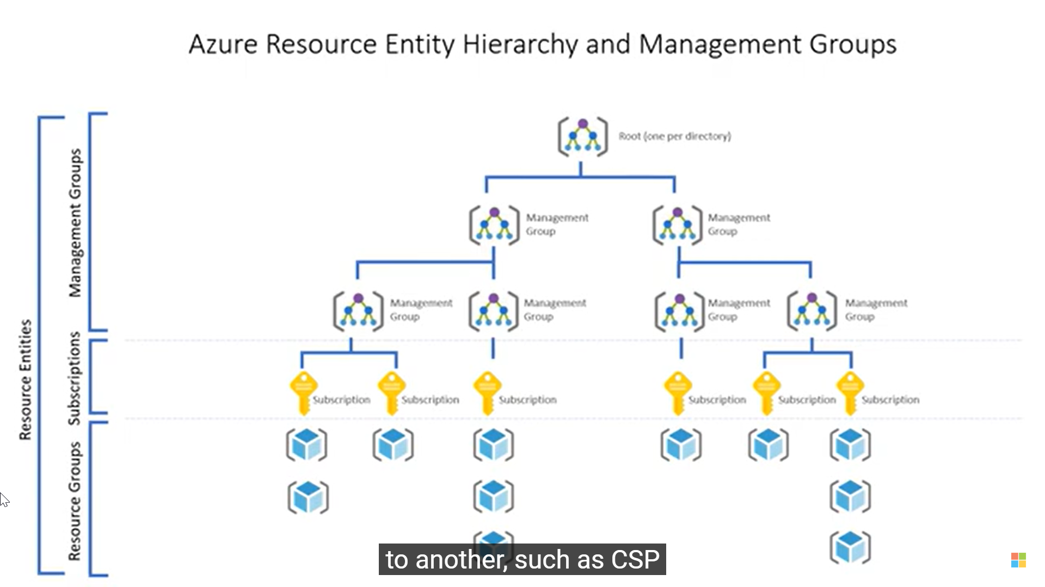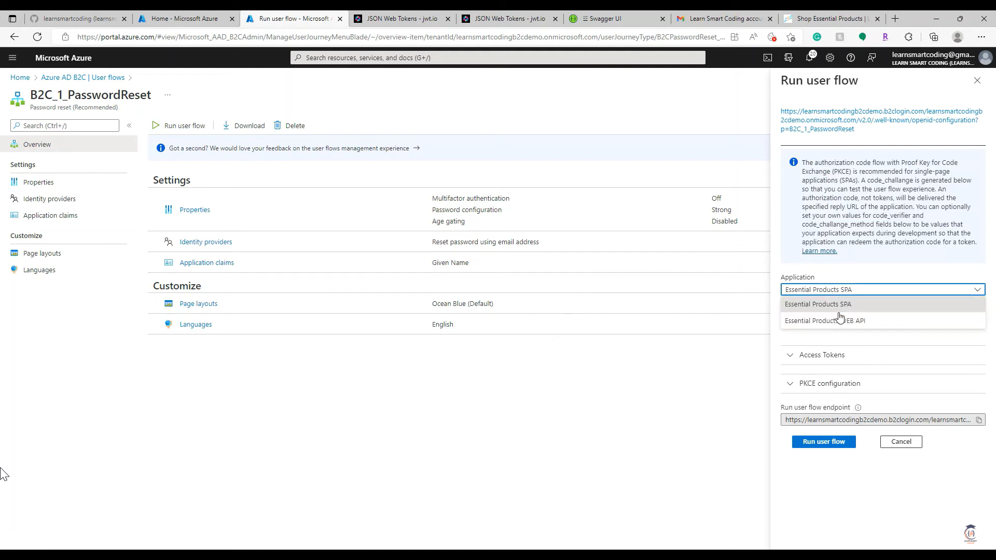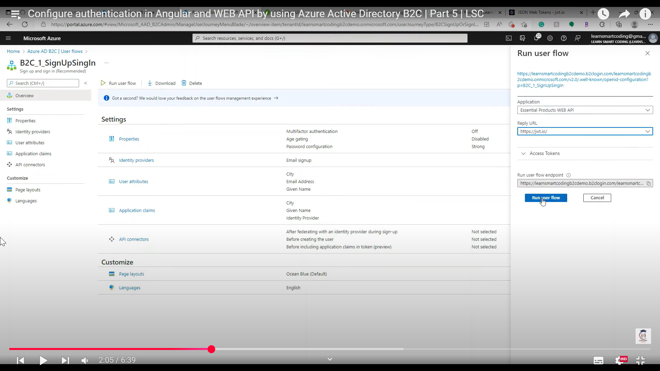

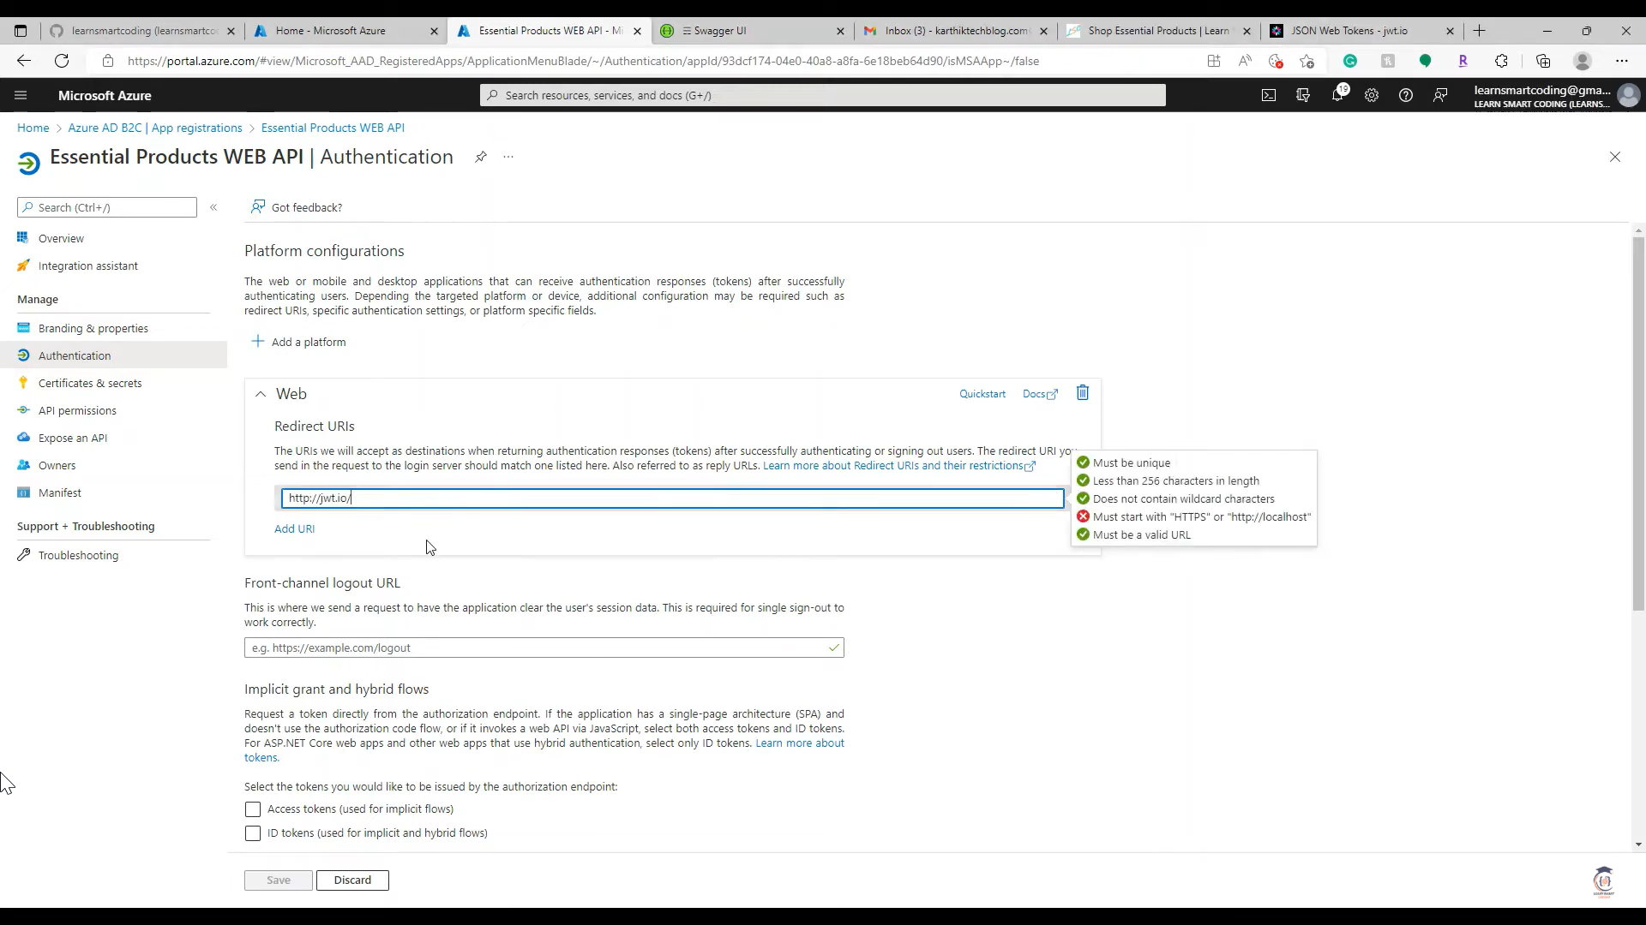

**1. Angular Integration with Azure AD B2C**

**Install MSAL Library**

Run the following commands to add the required libraries:

**npm install @azure/msal-browser @azure/msal-angular**

**Configure MSAL in Angular**

In your app.module.ts, configure the MSAL module:

|  |
| --- |
| import { NgModule } from '@angular/core';  import { BrowserModule } from '@angular/platform-browser';  import { MsalModule, MsalInterceptor, MsalService, MSAL_INSTANCE, MSAL_INTERCEPTOR_CONFIG, MsalInterceptorConfiguration } from '@azure/msal-angular';  import { PublicClientApplication, InteractionType } from '**@azure/msal-browser';**  import { HTTP_INTERCEPTORS, HttpClientModule } from '@angular/common/http';  const b2cPolicies = {  names: {  signUpSignIn: 'B2C_1_signup_signin',  },  authorities: {  signUpSignIn: {  authority: 'https://<tenant-name>.b2clogin.com/<tenant-name>.onmicrosoft.com/B2C_1_signup_signin',  },  },  authorityDomain: '<tenant-name>.b2clogin.com',  };  function MSALInstanceFactory(): PublicClientApplication {  return new PublicClientApplication({  auth: {  clientId: '<spa-client-id>',  authority: b2cPolicies.authorities.signUpSignIn.authority,  redirectUri: 'http://localhost:4200',  },  cache: {  cacheLocation: 'localStorage',  storeAuthStateInCookie: true,  },  });  }  function MSALInterceptorConfigFactory(): MsalInterceptorConfiguration {  return {  interactionType: InteractionType.Redirect,  protectedResourceMap: new Map([  ['https://<api-base-url>/', ['api.read', 'api.write']],  ]),  };  }  @NgModule({  declarations: [/* Your Components */],  imports: [  BrowserModule,  HttpClientModule,  MsalModule.forRoot(MSALInstanceFactory, MSALInterceptorConfigFactory),  ],  providers: [  { provide: HTTP_INTERCEPTORS, useClass: MsalInterceptor, multi: true },  ],  bootstrap: [/* Your Root Component */],  })  export class AppModule {} |

**Add Login and Logout in Angular**

|  |
| --- |
| **i**mport { Component } from '@angular/core';  import { MsalService } from '@azure/msal-angular';  @Component({  selector: 'app-root',  template: `  <button (click)="login()">Login</button>  <button (click)="logout()">Logout</button>  `,  })  export class AppComponent {  constructor(private msalService: MsalService) {}  login() {  this.msalService.loginRedirect();  }  logout() {  this.msalService.logoutRedirect();  }  } |

**2. API Integration with Azure AD B2C**

**Add Authentication Middleware in .NET API**

**dotnet add package Microsoft.AspNetCore.Authentication.JwtBearer**

Update Program.cs or Startup.cs to add JWT Bearer authentication:

|  |
| --- |
| using Microsoft.AspNetCore.Authentication.JwtBearer;  using Microsoft.IdentityModel.Tokens;  var builder = WebApplication.CreateBuilder(args);  **builder.Services.AddAuthentication(JwtBearerDefaults.AuthenticationScheme)**  **.AddJwtBearer(options =>**  {  options.Authority = "https://<tenant-name>.b2clogin.com/<tenant-name>.onmicrosoft.com/B2C_1_signup_signin/v2.0/";  options.Audience = "<api-client-id>";  options.TokenValidationParameters = new TokenValidationParameters  {  ValidateIssuer = true,  ValidIssuer = "https://<tenant-name>.b2clogin.com/<tenant-name>.onmicrosoft.com/v2.0/",  };  });  builder.Services.AddAuthorization();  var app = builder.Build();  app.UseAuthentication();  app.UseAuthorization();  app.MapControllers();  app.Run(); |

**Secure API Endpoints**

|  |
| --- |
| using Microsoft.AspNetCore.Authorization;  using Microsoft.AspNetCore.Mvc;  [ApiController]  [Route("api/[controller]")]  public class ProductController : ControllerBase  {  [HttpGet]  **[Authorize]**  public IActionResult GetProducts()  {  return Ok(new[] { "Product 1", "Product 2" });  }  } |

**3. Test Authentication**

**Test Angular App**

1. Run the Angular app: ng serve.
2. Click **Login** to trigger the Azure AD B2C sign-in flow.
3. After signing in, the MSAL interceptor will automatically attach the token to API requests.

**Test API**

1. Use Postman to test API endpoints:
   * Add the token from the Angular app in the Authorization header:  
     Authorization: Bearer <access_token>.
2. Decode the token at [jwt.io](https://jwt.io) to verify its claims.

**4. Without APIM**

* The above setup works without Azure API Management (APIM). Ensure:
  + Proper token validation in the API.
  + Scopes (api.read, api.write) are enforced in your application logic.

**1. System Design & Architecture Questions**

**1. How would you design a scalable IoT solution using Azure IoT Hub or AWS Greengrass?**

**Answer:**

A scalable IoT solution should consider **device connectivity, data ingestion, processing, storage, and analytics**.

**Key components in Azure IoT:**

* **Azure IoT Hub**: Manages device-to-cloud and cloud-to-device communication using MQTT/AMQP.
* **Azure Stream Analytics**: Processes real-time telemetry data.
* **Azure Functions / Event Grid**: Reacts to IoT events.
* **Azure Cosmos DB / Data Lake**: Stores structured and unstructured data.

**Key components in AWS IoT:**

* **AWS IoT Core**: Manages device communication.
* **AWS Greengrass**: Runs machine learning (ML) and processes data at the edge.
* **Amazon Kinesis / Lambda**: Processes data streams.
* **Amazon S3 / DynamoDB**: Stores the processed data.

**Scalability Considerations:**

* **Device Management**: Use **Azure IoT Device Provisioning Service (DPS)** for bulk device provisioning.
* **Security**: Use **X.509 certificates** for authentication.
* **Data Ingestion**: Use **Azure Event Hubs** for high-throughput streaming.

**2. What are the key design considerations when architecting a Cloud-Native Microservices solution?**

**Answer:**

A cloud-native microservices architecture follows these principles:

* **Decentralized Data Management**: Use polyglot persistence (SQL, NoSQL).
* **Service Autonomy**: Each microservice should function independently.
* **API Gateway**: Use **Azure API Management** or **Kong** to manage APIs.
* **Asynchronous Communication**: Use **Azure Service Bus / Kafka**.
* **Resilience Patterns**: Implement **circuit breakers** (Polly in .NET).
* **Scalability**: Deploy using **Kubernetes (AKS)**.

**3. How would you handle real-time message processing in an IoT ecosystem using MQTT/AMQP?**

**Answer:**

* **MQTT**: Lightweight protocol used for IoT devices.

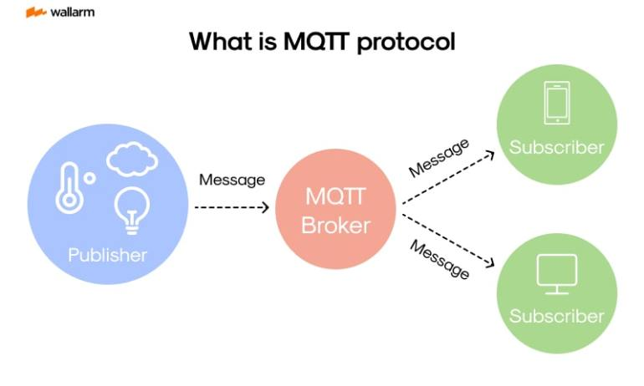

* **AMQP**: Message-oriented middleware (used in RabbitMQ, Azure Service Bus).
* 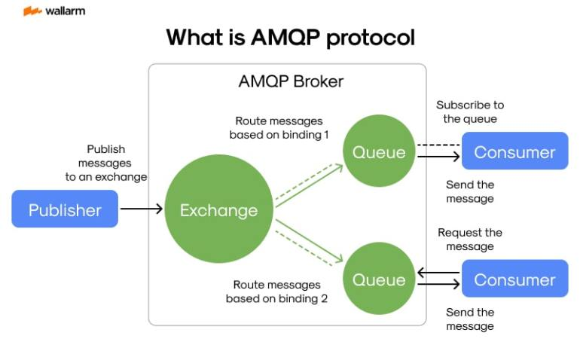

**Azure Implementation:**

1. IoT devices send messages to **Azure IoT Hub (MQTT/AMQP)**.
2. Data is streamed to **Azure Event Hubs** for real-time analytics.
3. **Azure Stream Analytics** filters and routes messages.

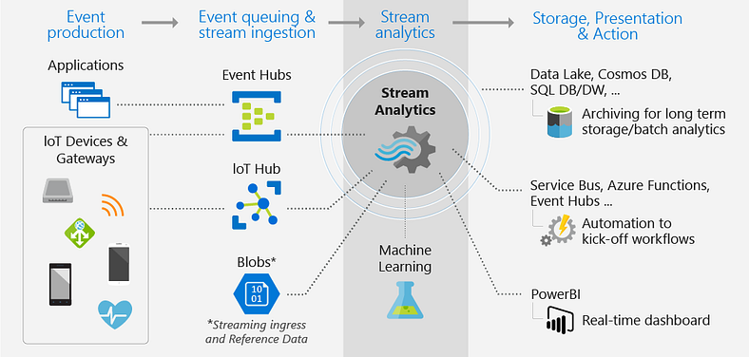

1. Data is stored in **Azure Data Lake** for long-term storage.

**Optimizations:**

* **Use Shared Access Policies** to restrict access.
* **Use partitions** in **Azure Event Hubs** to handle high throughput.

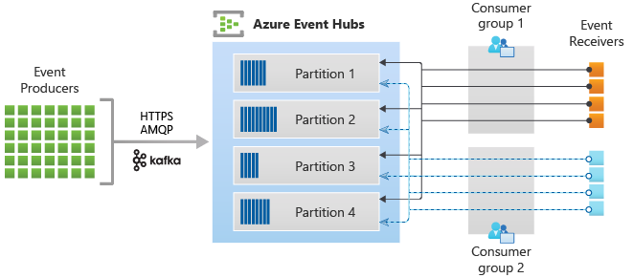

**4. What are the benefits and trade-offs of stateless vs. stateful services in a cloud-based architecture?**

**Answer:**

| **Feature** | **Stateless** | **Stateful** |
| --- | --- | --- |
| **Data Persistence** | No data storage in memory | Stores session data |
| **Scalability** | Easy to scale | Harder to scale |
| **Resilience** | Resilient to failures | More complex failover |
| **Example** | REST API | Caching, databases |

**Trade-offs**:

* **Stateless** services are best for **scalability** (e.g., API Gateways).
* **Stateful** services require **replication and persistence** (e.g., Redis for caching).

Redis master writes/updates data to Redis slave nodes. Redis server run in two modes:

* Master Mode (Redis Master) ∙
* Slave Mode (Redis Slave/Redis Replica)

We can configure Redis to choose a mode to write and read from. It is recommended to serve writes through the Redis leader and reads through the Redis follower.

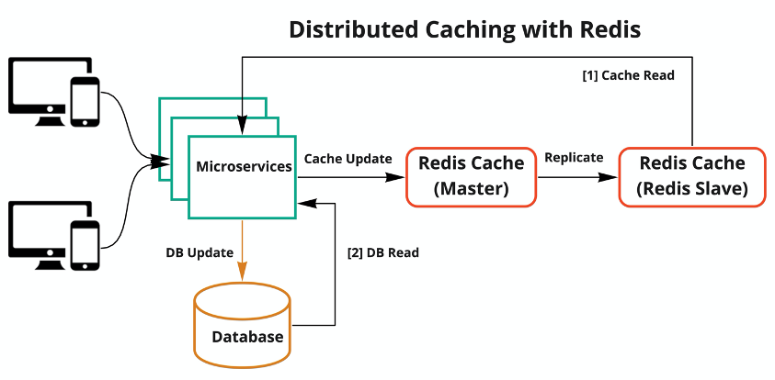

**2. IoT & Cloud Questions**

**5. How do you handle device authentication and authorization in an IoT ecosystem?**

**Answer:**

* **Device Identity Management**: Use **X.509 certificates** instead of shared keys.
* **OAuth 2.0 / JWT**: Secure communication between IoT devices and APIs.
* **Role-Based Access Control (RBAC)**: Assign access policies using **Azure AD / AWS IAM**.

**Example**:

* Use **Azure IoT Hub’s Device Provisioning Service (DPS)** to manage authentication.

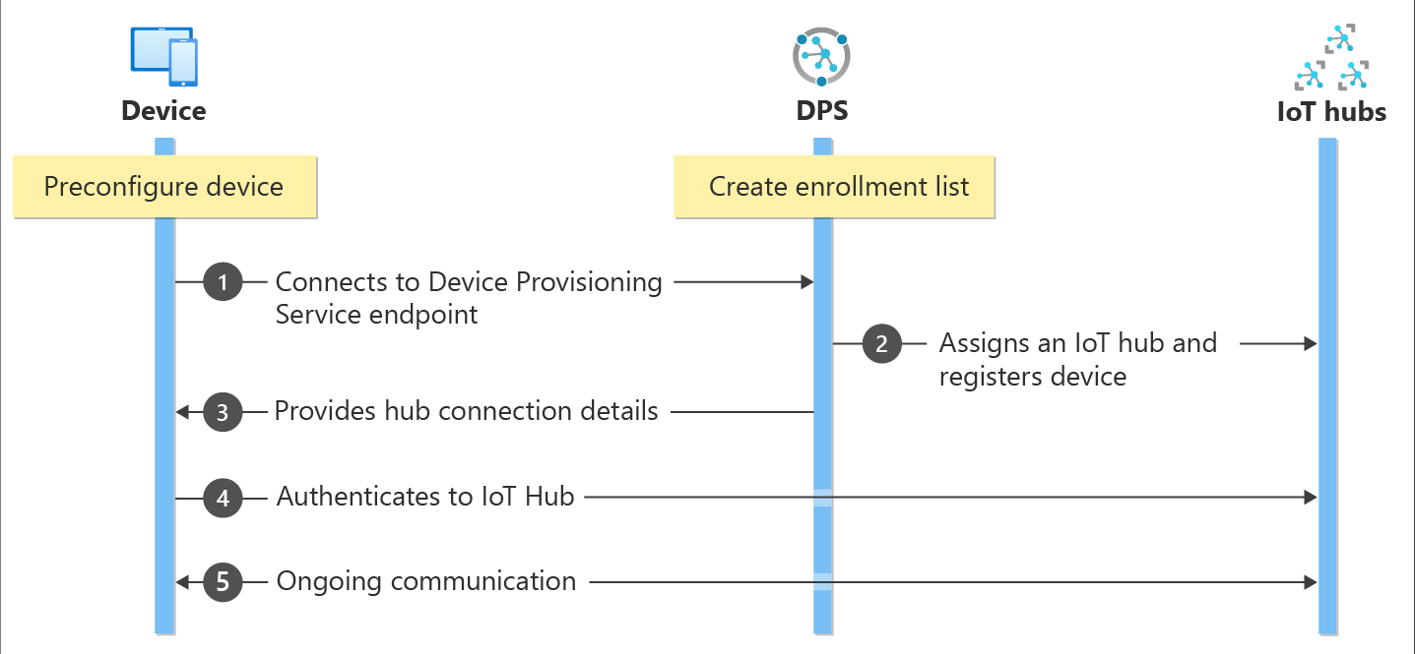

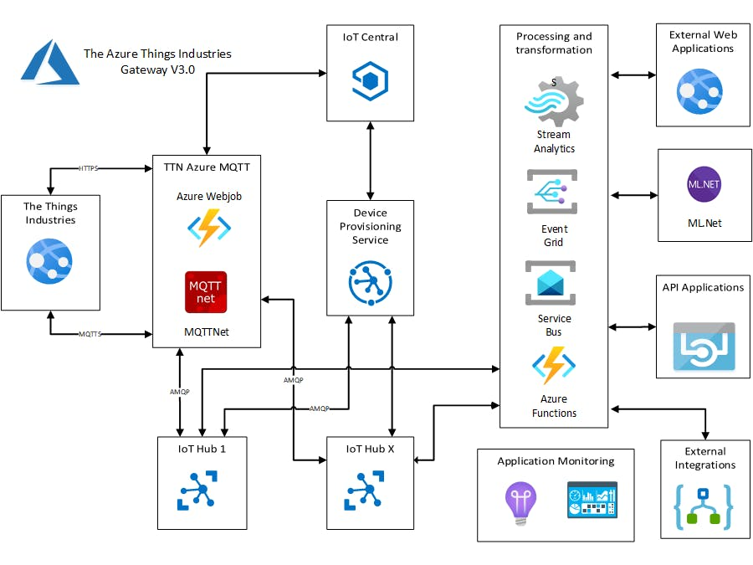

**6. What security measures would you implement for an IoT Edge deployment?**

**Answer:**

1. **Data Encryption**: Encrypt data at rest (AES-256) and in transit (TLS 1.2+).
2. **Network Security**: Restrict device access using **firewall rules**.
3. **Zero Trust Model**: Implement **device identity validation**.

**Example**:

* Use **Azure Defender for IoT** for real-time threat detection.

Azure Defender for IoT is a Microsoft security solution designed to provide real-time threat detection for IoT and OT devices by continuously monitoring network traffic and device activity, generating alerts when suspicious behavior is identified, allowing for proactive response to potential security breaches within an industrial or enterprise IoT environment;

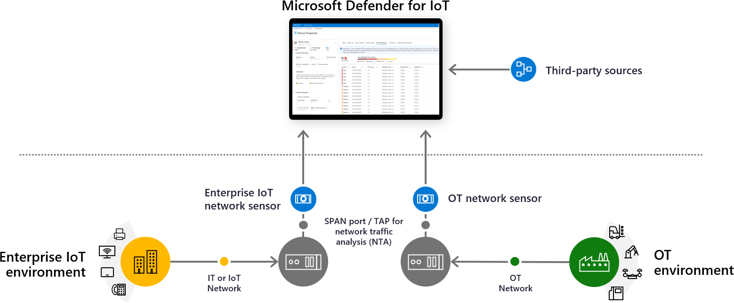

**3. .NET Core & API Design Questions**

**7. How would you design a highly performant RESTful API using .NET Core?**

**Answer:**

* Use **.NET 8 Minimal APIs** for lightweight APIs.
* **Enable caching** using **Redis** or **Response Caching Middleware**.
* **Rate limiting** using **AspNetCoreRateLimit**.
* **Use DTOs** to avoid over-fetching data.

**8. What are best practices for unit testing and API testing in .NET Core?**

**Answer:**

* Use **xUnit / NUnit** for unit tests.
* **Mock dependencies** using **Moq**.
* **Use FluentAssertions** for readable assertions.

Example:

csharp

CopyEdit

var mockRepo = new Mock<IOrderService>();

mockRepo.Setup(service => service.GetOrder(1)).ReturnsAsync(order);

**4. CI/CD & DevOps Questions**

**9. How would you set up a CI/CD pipeline for a .NET Core application in Azure DevOps?**

**Answer:**

1. **CI Pipeline**
   * Run unit tests using **dotnet test**.
   * Build using **dotnet publish**.
2. **CD Pipeline**
   * Deploy to **Azure App Service / AKS**.
   * Implement **blue-green deployment**.

Example **azure-pipelines.yml**:

**trigger**:

- main

**pool**:

vmImage: 'ubuntu-latest'

**steps:**

- **task**: UseDotNet@2

**inputs**:

packageType: sdk

version: '8.x'

- **script: dotnet build --configuration Release**

- script: dotnet test --logger trx

**5. Messaging & Event-Driven Architecture Questions**

**10. How would you design an event-driven architecture using Azure Event Hubs?**

**Answer:**

1. IoT devices send events to **Azure IoT Hub**.
2. **Azure Event Hubs** processes and routes events.
3. **Azure Functions / Logic Apps** process data.
4. Data is stored in **CosmosDB / Data Lake**.

**11. Can you explain the Saga Pattern and when you would use it?**

**Answer:**

The **Saga Pattern** is used for **managing distributed transactions** in microservices.

**Approaches:**

1. **Choreography**: Each service publishes an event for the next service.
2. **Orchestration**: A central **Saga Coordinator** manages transactions.

Example:

* **Order Processing System**
  + Payment Service → Inventory Service → Shipping Service.
  + If one service fails, Saga triggers a rollback.

**Two-Phase Commit(2PC) - Distributed Design Patterns**

**Phase 1 — Prepare Phase**: The coordinator node sends a prepare message to all participating nodes, asking them if they are ready to commit the transaction. Each participant acquires a “lock” on the resource/s and replies with either a Yes or No message, indicating whether they can commit.

**Phase 2 — Commit Phase**: The coordinator decides whether to commit or abort the transaction based on the responses received in the Prepare phase. If all participants have responded with a Yes message, the coordinator sends a commit message to all the participants. If any participant has responded with a No message, the coordinator sends an abort message to all the participants, and the transaction is rolled back.

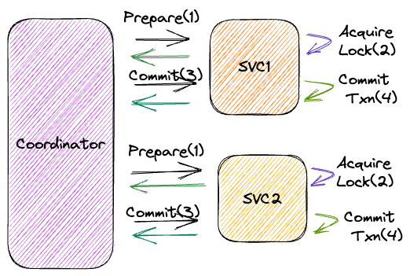

<https://medium.com/design-microservices-architecture-with-patterns/saga-pattern-for-microservices-distributed-transactions-7e95d0613345>

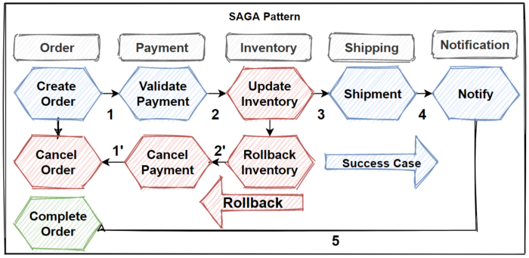

**Choreography Saga Pattern**

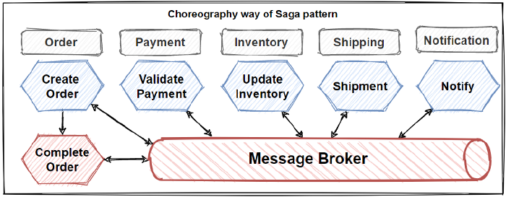

**Orchestration Saga Pattern**

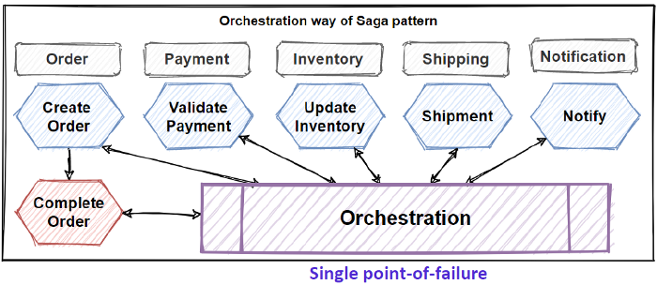s

**Advantages of Two-Phase Commit Protocol**

1. **Consistency**: 2PC guarantees that either all participating nodes commit the transaction or all of them roll it back, ensuring consistency across the distributed system.
2. **Atomicity**: The 2PC protocol ensures that the transaction is an atomic operation, meaning it either completes successfully or not at all.
3. **Simplicity**: The 2PC protocol is relatively simple and easy to understand, making it an attractive option for coordinating transactions in distributed systems.

**Pitfalls of Two-Phase Commit Protocol**

1. **Scalability**: The 2PC protocol can be challenging to scale for large distributed systems. The protocol requires all participating nodes to coordinate with each other, increasing communication overhead as the number of nodes in the system grows.
2. **Single Point of Failure:** The coordinator node is a single point of failure in the 2PC protocol. If the coordinator fails, the entire transaction fails, and the system will need to restart the transaction from scratch.
3. **Performance:** The 2PC protocol can have a significant impact on the performance of the system, particularly in high write throughput scenarios.

This covers **detailed answers** for key interview questions. Let me know if you need **deep dives, mock interviews, or specific areas explained further!** 🚀

**You said:**

Use polyglot persistence (SQL, NoSQL)

can you explain

**ChatGPT said:**

**What is Polyglot Persistence?**

**Polyglot persistence** refers to using multiple types of databases (SQL and NoSQL) in a single system, based on the best fit for a specific use case. Instead of relying on just one database technology for everything, different components of the system use different databases optimized for their workloads.

**Why Use Polyglot Persistence?**

Different data storage needs require different databases. For example:

* **Relational data with strict consistency?** → Use **SQL (e.g., SQL Server, PostgreSQL, MySQL)**
* **High-velocity, semi-structured data?** → Use **NoSQL (e.g., MongoDB, Cosmos DB, DynamoDB)**
* **Real-time analytics?** → Use **Time-series or Columnar databases (e.g., InfluxDB, Apache Cassandra)**
* **Graph-based relationships?** → Use **Graph databases (e.g., Neo4j, Azure Cosmos DB Graph API)**

**Example: Polyglot Persistence in a Cloud-Native Microservices System**

Imagine you're building an **IoT-based fleet tracking system**. Each component has different storage needs:

| **Component** | **Data Type** | **Best-Fit Database** |
| --- | --- | --- |
| **User Management** | Structured, relational | **SQL Server / PostgreSQL** |
| **Telemetry Data** | High-volume, time-series | **Azure Cosmos DB / Cassandra** |
| **Vehicle Tracking** | Geospatial queries | **PostGIS (PostgreSQL) / MongoDB** |
| **Real-time Analytics** | Stream processing data | **Azure Data Explorer / Kafka** |

Each service interacts with its own database, but APIs enable communication between services.

**When Should You Avoid Polyglot Persistence?**

* **Small-scale applications** where a single database can handle all requirements.
* **Increased complexity in maintenance** (e.g., managing multiple database connections, backups).
* **Latency concerns** if data synchronization between multiple databases becomes an issue.

**Key Takeaways for an Interview**

1. **Justify when to use SQL vs. NoSQL.**
2. **Explain how microservices can use different databases without tight coupling.**
3. **Mention trade-offs like increased complexity, latency, and cost.**
4. **Provide real-world examples like IoT, e-commerce, or financial systems.**

**Azure IoT Hub with .NET and MQTT/AMQP**

Azure IoT Hub enables bi-directional communication between IoT devices and the cloud using **MQTT, AMQP, or HTTPS**. Below is a **.NET Core example** demonstrating how to send telemetry data from a simulated IoT device to Azure IoT Hub.

**1. Setting Up Azure IoT Hub**

**Step 1: Create an IoT Hub in Azure**

1. Go to **Azure Portal** → Search for **IoT Hub** → Click **Create**.
2. Choose a **Resource Group**, Region, and Pricing Tier.
3. Once created, navigate to **IoT Devices** → Click **+ Add Device**.
4. Copy the **Connection String (Primary Key)** to use in .NET.

**2. Install Required NuGet Packages**

Install the **Microsoft.Azure.Devices.Client** library in your .NET project:

sh

CopyEdit

dotnet add package Microsoft.Azure.Devices.Client

**3. .NET Code for Sending Device Telemetry (MQTT/AMQP)**

**Simulated IoT Device (Send Telemetry Data)**

|  |
| --- |
| using System;  using System.Text;  using System.Threading.Tasks;  using Microsoft.Azure.Devices.Client;  using Newtonsoft.Json;  class Program  {  // Replace with your device connection string from Azure IoT Hub  private static readonly string deviceConnectionString = "<Your Device Connection String>";    // Create a device client using MQTT  private static readonly DeviceClient deviceClient = DeviceClient.CreateFromConnectionString(deviceConnectionString, TransportType.Mqtt);  static async Task Main(string[] args)  {  Console.WriteLine("Simulated IoT Device Running...\n");  while (true)  {  // Generate random telemetry data  var telemetryData = new  {  temperature = new Random().Next(20, 35),  humidity = new Random().Next(40, 80),  timestamp = DateTime.UtcNow  };  // Convert data to JSON format  string messageJson = JsonConvert.SerializeObject(telemetryData);  var message = new Message(Encoding.UTF8.GetBytes(messageJson))  {  ContentType = "application/json",  ContentEncoding = "utf-8"  };  // Send message to Azure IoT Hub  await deviceClient.SendEventAsync(message);  Console.WriteLine($"Telemetry sent: {messageJson}");  await Task.Delay(5000); // Wait 5 seconds before sending the next message  }  }  } |

**4. .NET Code for Receiving Cloud-to-Device Messages (C2D)**

IoT devices can also receive commands from Azure IoT Hub.

|  |
| --- |
| static async Task ReceiveCloudToDeviceMessagesAsync()  {  while (true)  {  Message receivedMessage = await deviceClient.ReceiveAsync();  if (receivedMessage != null)  {  string messageData = Encoding.UTF8.GetString(receivedMessage.GetBytes());  Console.WriteLine($"Received C2D Message: {messageData}");  // Complete the message to remove it from the queue  await deviceClient.CompleteAsync(receivedMessage);  }  }  } |

Call ReceiveCloudToDeviceMessagesAsync(); inside Main() to start listening.

**5. Setting Up an Azure IoT Hub Service Client (Cloud-Side)**

To send messages **from the cloud** to the IoT device, create a **Service Client**.

|  |
| --- |
| using System;  using System.Text;  using System.Threading.Tasks;  using Microsoft.Azure.Devices;  class Program  {  // Azure IoT Hub connection string (NOT device connection string)  private static readonly string hubConnectionString = "<Your IoT Hub Connection String>";  private static readonly string deviceId = "<Your Device ID>";    static async Task Main(string[] args)  {  using var serviceClient = ServiceClient.CreateFromConnectionString(hubConnectionString);  string commandMessage = "Turn on the fan";  var message = new Message(Encoding.ASCII.GetBytes(commandMessage));    await serviceClient.SendAsync(deviceId, message);  Console.WriteLine($"Sent command to device: {commandMessage}");  }  } |

**6. Running the Application**

1. Run the **device simulator** to start sending telemetry data:

dotnet run

1. Run the **service client** to send a command to the IoT device.

**7. Key Takeaways**

✅ **IoT Hub handles device-to-cloud (D2C) and cloud-to-device (C2D) communication**  
✅ **MQTT/AMQP protocols optimize real-time messaging**  
✅ **Use DeviceClient in .NET for secure telemetry transmission**  
✅ **Implement message processing and security best practices**

**2. Setting Up Azure Stream Analytics**

**Step 1: Create an IoT Hub (if not already done)**

* Go to **Azure Portal** → Create **IoT Hub** → Add a device and copy the connection string.

**Step 2: Create an Azure Stream Analytics Job**

1. Navigate to **Azure Stream Analytics** → Click **Create**.
2. Choose a **Resource Group**, Region, and Streaming Units.
3. Click **Inputs** → Choose **Azure IoT Hub**.
4. Click **Outputs** → Choose where to store processed data (SQL DB, Blob Storage, Power BI, etc.).
5. Click **Query** → Define **SQL-like transformations**.

**3. .NET Code to Simulate IoT Data (MQTT)**

Let's simulate **temperature sensor data** and send it to Azure IoT Hub.

**Simulated IoT Device (C#)**

|  |
| --- |
| using System;  using System.Text;  using System.Threading.Tasks;  using Microsoft.Azure.Devices.Client;  using Newtonsoft.Json;  class Program  {  private static readonly string deviceConnectionString = "<Your IoT Device Connection String>";  private static readonly DeviceClient deviceClient = DeviceClient.CreateFromConnectionString(deviceConnectionString, TransportType.Mqtt);  static async Task Main(string[] args)  {  while (true)  {  var telemetryData = new  {  deviceId = "sensor01",  temperature = new Random().Next(20, 40),  humidity = new Random().Next(30, 80),  timestamp = DateTime.UtcNow  };  string messageJson = JsonConvert.SerializeObject(telemetryData);  var message = new Message(Encoding.UTF8.GetBytes(messageJson))  {  ContentType = "application/json",  ContentEncoding = "utf-8"  };  await deviceClient.SendEventAsync(message);  Console.WriteLine($"Sent: {messageJson}");  await Task.Delay(5000);  }  }  } |

📌 **This sends IoT telemetry data every 5 seconds to Azure IoT Hub.**

**4. Writing an Azure Stream Analytics Query**

Now, we process **incoming IoT data** to detect temperature anomalies.

**Example Query in Azure Stream Analytics**

|  |
| --- |
| SELECT  deviceId,  temperature,  humidity,  timestamp,  CASE  WHEN temperature > 35 THEN 'High Temperature Alert'  ELSE 'Normal'  END AS AlertStatus  **INTO [SQLDatabaseOutput]**  **FROM [IoTHubInput]**  WHERE temperature IS NOT NULL |

**What this does:**

✅ Reads data from **IoT Hub**  
✅ Filters **non-null temperatures**  
✅ Adds an **alert** if **temperature > 35°C**  
✅ Saves processed data to an **SQL Database**

**5. Storing Processed Data in SQL Server**

* Set **Azure SQL Database** as an **output** in the ASA job.
* Create a table in SQL Server to store processed data.

|  |
| --- |
| CREATE TABLE IoT_Alerts (  deviceId NVARCHAR(50),  temperature FLOAT,  humidity FLOAT,  timestamp DATETIME,  AlertStatus NVARCHAR(50)  ); |

**6. Visualizing Data in Power BI**

To visualize real-time IoT data in **Power BI**:

1. **Set Power BI as Output** in Azure Stream Analytics.
2. Create a **Dashboard in Power BI**.
3. Connect **Power BI Streaming Dataset** to ASA.

📌 **Example:** Show a **real-time temperature chart** with **alerts**.

**7. Key Takeaways for Interview**

💡 **How Azure Stream Analytics Works** → Real-time SQL-based data processing  
💡 **How to Use IoT Hub as Input** → Connect IoT devices for telemetry  
💡 **Use Case: Temperature Anomaly Detection** → Alerts for high temperature  
💡 **SQL Query-Based Transformation** → Aggregate, filter, and process IoT data  
💡 **Integration with SQL & Power BI** → Store and visualize real-time data

Would you like an **Event Hub scenario** or a **custom real-time dashboard example** next? 🚀